# Profile

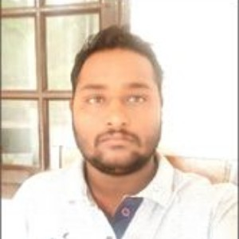

## Asst. Manager(Mines) ACC CEMENT LIMITED (LAFARGE HOLCIM GROUP)

**ACADEMIC QUALIFICATIONS**

Secondary Exam 2005

Board Of Secondary Education ODISHA, 67%

Higher Sec. Exam 2007

HSCE, ODISHA, 60%

# PROFESSIONAL QUALIFICATION

Diploma In Mining 2010

Orissa School Of Mining Engineering, Keonjhar,Odisha, State Council Of Technical Education,Odisha

## 87%

B TECH. Mining 2016

Institution Of Engineers India, Kolkata, IEI

## 6.4 CGPA

**COMPETENCY CERTIFICATE**

**1st CLASS Mines Manager Competency certificate** Awarded by Directorate General of Mines Safety, Dhanbad (Jharkhand).

# TRAINING EXPERIENCEBASANTA KUMAR SUTAR

# Personal info

 25/06/1990

 [basantakumarsutar@gmail.com](mailto:basantakumarsutar@gmail.com)

 7550350701

Permanent Address

 AT/PO- JABARA, VIA-JENAPUR, P.S-KUAKHIA, DIST-JAJPUR STATE-ODISHA, PIN-755023

Present Address

 Q NO- C-6, ACC COLONY DUNGRI, PS-AMBABHONA DIST- BARGARH STATE- ODISHA, PIN-768052

 7550350701

 S/O Sh. SANTOSH KUMAR SUTAR

# Hobbies

1. URANIUM, Uranium Corporation of India Limited, Jaduguda- 2 months
2. COAL, Mahanadi Coal Limited, Talcher - 2 months
3. IRON ORE, TATA Iron and Steel Corporation Limited, Joda - 2 months
4. IRON ORE, SAIL, TENSA, BARBIL - 2 months

# WORKING EXPERIENCE

Asst. Manager(Mines) 07/2010 – present ACC CEMENT LIMITED, (LAFARGE HOLCIM GROUP)

## JOB RESPONSIBILITIES:-

Looking after the Production, Development planning. Looking after the operation & maintenance of HEMM like Excavators, dumpers.

Look after the Deep hole drilling, advanced technology blasting (electronic blasting, controlled blasting technique) .

Looking after dump management, dumping operation, bio diversity management.

SAP MODULE ISO9001,14001,OHS, HSMS AUDIT.

Lookin after mine planning, surveying, geological mapping, quality control tools like QSO, QM.

To work as a close knit team and keep organizational goal as top priority



Exploring distant lands



Sports