CURRICULUM VITAE
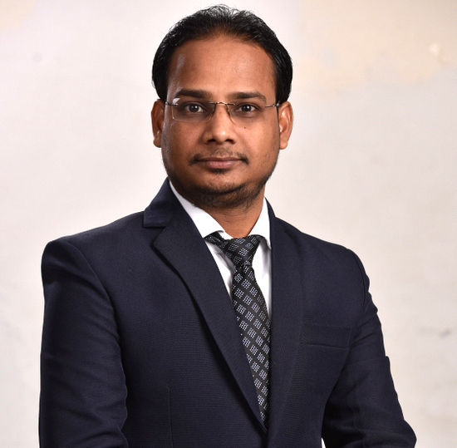

Name- Gopal Chandra Barik
Mother’s Name- Gayatri Barik
Father’s Name- Krushna Chandra Barik
OBJECTIVE

I am looking forward to be a part of your esteemed organization that will provide me a competent atmosphere helping me in my growth professionally and also set afore me an opportunity to become a contributor in the success of your company. This would, furthermore, help me to fine-tune my skills and knowledge as it would be a good exposure to the working system at the Industry-level limit.

ACADEMIC DETAILS

Exam | Year Of Passing | Name of the Institution | Board/ University | Division/ Grade
Web Designing | 2010 | PENTASOFT INSTITUTE, Bhubaneswar. | PENTASOFT | Passed
Multimedia | 2009 | NICET INSTITUTE, Ashok Nagar, Bhubaneswar. | NICET | Passed
P.G. | 2016 | Utkal University, Vanivihar | Utkal University | Passed
+3 | 2014 | Lachhaman Bala Jew Degree College Angalo, Jajpur | Utkal University, Odisha | Passed
+2 | 2003 | Maa Tarini, Mohavidyalaya, Panikoili | CHSE, Orissa | 2nd
10th | 2001 | Panikoili High School, Panikoili | BSE, Orissa | 3rd

ADITIONAL EDUCATIONAL DETAILS

Post Graduate Diploma in Computer Application (PGDCA) Brilliant Institute Jajpur Road, Jajpur.

Tally Completed 5.0 & 7.5 Brilliant Institute Jajpur Road, Jajpur.

AREAS OF INTEREST

Web Designer Language (HTML, DHTML, DREAMWEAVER, JAVA, A.S.P, FLASH,
PHOTOSHOP)

GRAPHICS: Photoshop, Corel draw, PageMaker, Illustrator, Flash, Premier and 3d.

EXPERIENCE DETAILS

- Six Months Experience in NARAYANA OLYMPIAD SCHOOL, BBSR as a Computer teacher.

- 3 years Experience in INEET Medical Institute Khandagiri, BBSR as a computer operator With Designer. 12th May 2014 to Feb. 2017

- Presently Working in St. Xaviers Group of School Bhiwani, Haryana as a ERP Developer cum- Designer with Graphic Designer March 2017 to 2020 till date.

PERSONAL DETAILS

Date of Birth : 12 April 1986
Religion : Hindu
Nationality : Indian
Sex : Male
Marital Status : Unmarried
Languages known : Oriya, Hindi, English, Bengali
E-mail : gopalchandrabarik68@gmail. com
Mobile : 9777979520, 7978020543

PRESENT ADDRESS

5km. Bhiwani – Delhi Highway, Near ITS College Bhiwani, Haryana.
PERMANENT ADDRESS
At- Soti, Po- Hatasahi,
Via- Panikoili, P.S.-Panikoili
Dist- Jajpur, Pin-755043, Odisha.
DECLARATION

I do hereby declare that the information furnished above is true to the best of my knowledge and belief.

Date:
Place: Bhubaneswar Signature: GOPAL CHANDRA BARIK

