**NIKHIL KAMTI**

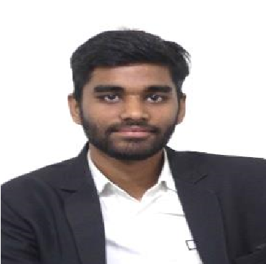

nikhil5226kamti@gmail.com 8434339141



**Contact Address:**

House no 3, C-block, Road no.=1, Shiv Singh Bagan, Sidhgora, Jamshedpur,831009

# CAREER OBJECTIVE

To obtain a position that will allow me to utilize my computer skills and willingness to learn in making an organization successful.

# COMPUTER /TECHNICAL SKILLS

* LANGUAGE: BASIC OF JAVA, C, C++, Visual Basic 6.0
* DATABASE: SQL PLUS ➢ APPLICATION TOOLS:

MICROSOFT WORD, MICROSOFT POWER POINT

# EDUCATION QUALIFICATION

|  |  |  |  |  |
| --- | --- | --- | --- | --- |
| **Name of examination** | **Year of passing** | **Board /**  **University** | **Institution** | **Percentage** |
| GRADUATION  (BCA) | 2021 | KOLHAN  UNIVERSITY,  CHAIBASA | KARIM CITY  COLLEGE,  JAMSHEDPUR | 80.2%  (TILL  DATE) |
| INTERMEDIATE | 2018 | ISC | DAV PUBLIC SCHOOL,  AGRICO,  JAMSHEDPUR | 69.5% |
| MATRICULATION | 2016 | ICSE | DAV PUBLIC SCHOOL,  AGRICO,  JAMSHEDPUR | 74.2% |

# SOFT SKILLS

* Communication Skills
* Team Work
* Time Management
* Leadership Skills

# ACADEMIC ACHIEVEMENTS

* Participated in the National Service Scheme National Integration Camp in March 2020.
* Participated in One day Awareness Generation Programme on Drug Abuse Prevention & Capacity Building Sponsored by NISD in March 2020.
* Secured 2nd position in Model Competition held by Department of Computer Application in January 2019.
* Secured 2nd position in Hindi-Slogan Writing organized by NSS Unit of karim City College in December 2019.
* Secured 2nd position in Fund Raising Drive organized by NSS Unit of karim City College in December 2019.
* Participated in Election Drive organized by SWEEP in December2019.
* Participated in Annual Special Camp at adopted village Kopali in December 2018.

# DECLARATION

I hereby declare that all information given above is true to best of my knowledge and belief.

Date : 16/09/2020

Place : Jamshedpur