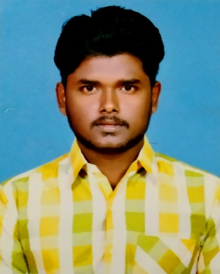
T.Selvaprakash
B.E Civil Engineer
 8667745908
 prakashselva036@gmail.com
 D2, Shencottai new police quarters,
Shencottai thaluk-627809, Tenkasi, Tamilnadu, India.
CAREER OBJETIVE
A responsible and honest professional seeking a challenging position in a growing and stable organization.

ACADEMIC DETAILS
COURSE | INSTITUTION | YEAR OF COMPLETION | PERCENTAGE/CGPA
B.E (civil) | Sri Shakthi Institute of Engineering and Technology, Coimbatore. | 2014-2018 | CGPA = 6.19
HSC  (XII) | Emmanuel Matric Higher Secondary School, Tenkasi. | 2012-2014 | 74.83%
SSLC  (X) | Emmanuel Matric Higher Secondary School, Tenkasi. | 2011-2012 | 83.8%
FIELD OF INTRESTS

- Environmental Engineering
- Surveying
- Site supervision

COMPUTER SKILLS

- Design using Autocad-2016
- MS Office
- HTML
IMPLANT TRAINING
CONSTRUCTION NAME | Duration
Sri Balaje Constructions (Tenkasi) | 1 month
Sri Selvamuthukummaran Builders (Tenkasi) | 10 days
Jeyes Builders (Tenkasi) | 10 days
Purpose: Gain Knowledge about Reinforcement of Beams and Slab, Placing of Concrete and Plastering, Waterproofing and soil nailing.

CO-CURRICULAR ACTIVITES

- 2017 Attended a National level workshop on ARCHITECTURAL DESIGN AND VALUATION OF MOVABLE PROPERTIES organised by SRI KRISHNA COLLEGE OF ENGINEERING AND TECHNOLOGY.

- 2017 Attended a workshop on ANGULAR JS and DIGITAL MARKETING organised by NATIONAL ENGIEERING COLLEGE.
- 2017 Attended a National level Technical Symposium on YUKTA:2K17 organised by PSG COLLEGE OF TECHNOLOGY AND APPLIED RESEARCH.

PROJECTS
PROJECT: 1
Institution : Sri Shakthi Institute of Engineering and Technology, Coimbatore.
Duration : 3 Months
Project Title : Planning, Analysing and Design of open Auditorium
Description : The project aim is to construct an open auditorium in our institute for the purpose of department functions, in this project we selected an area and planed, then the plan were fully analysed and designed using AUTOCAD-2016, STAAD Pro.
PROJECT: 2
Institution : Sri Shakthi Institute of Engineering and Technology, Coimbatore.
Duration : 6 Months
Project Title : Replacement of Aggregate in Concrete with Discarded Rubber Tyre Waste
Description : The project aim is to know the effect of partial replacement of coarse aggregate by rubber tyre chips on the fresh concrete property (e.g. slump test) and hardened concrete properties (e.g. compressive strength, split tensile strength, flexural strength).
PERSONAL PROFILE
Father Name : C.Thambidurai
Mother Name : T.Malini
Date of Birth : 13-11-1995
Gender : Male
Languages Known : Tamil, English, Malayalam
Mobile Number : 8667745908 (official)
Email Id : prakashselva036@gmail.com
Permanent address : L183A, TNHB colony, Tenkasi-627811, Tamilnadu, India
Hobbies : Listening music, Gardening, Volunteer work.
Mobility : Willing to relocate anywhere in India or abroad.
DECLARATION
I, hereby declare that above information are true to the best of my knowledge and I bear the responsibility for the correctness of the above mentioned particulars.

Place : Tenkasi 
Date : (T.Selvaprakash)

