**CURRICULUM VITAE**

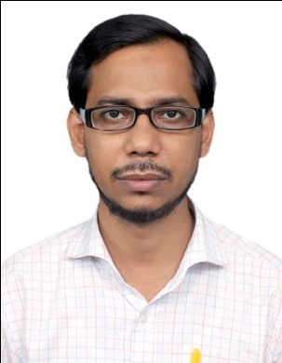

# MOBILE NO: +91 7278906771

**E-mail ID: -** [**shafialam09@gmail.com**](mailto:shafialam09@gmail.com)

**SHAFI ALAM**

S/o. Sk. Wazir

1/H/5, Ram Mohan Bera Lane,

P.O. ENTALLY

P.S. BENIAPUKUR

Dist. KOLKATA

PIN-700014 West Bengal

# 

## CAREER OBJECTIVE

**To succeed in an environment of growth and excellence and earn a job which provides me job Satisfaction and self development and help me to achieve personal as well as organization goals.**

## PERSONAL PROFILES

* Father’s Name : Sk. Wazir
* Permanent Address : 1/H/5, Ram Mohan Bera Lane, Kolkata–700014
* Date of Birth : 16th March 1979
* Sex : Male
* Nationality : Indian
* Religion : Islam
* Language Known : English, Hindi Urdu & Bengali
* Marital Status : Single
* Hobbies : Playing cricket, Working with Computer, Surfing

Internet and reading books.

## EDUCATIONAL PROFILES

|  |  |  |
| --- | --- | --- |
| **Course** | **Board/University** | **Year** |
| Higher Secondary | West Bengal Council of Higher Secondary education | 1998 |
| Matriculation | West Bengal Board of Secondary Education | 1996 |

## COMPUTER PROFICIENCY

Knowledge in computer ( Operating Ms-dos, Ms-Word, Excel, Word, Power Point & Internet ).

Account Assistant using Tally and ERP.

## CAREER PATH

* **Company Name** : Lalani Infotech L**td**
* Industry Nature : IT Industry
* Designation : Account Assistant / Cashier.
* Location : Kolkata
* Duration : 04th August 2009 to Till date.

## EXPERIENCE

Presently I am working as a Cashier and Account Assistant. Nine (9) years experience as a cashier.

## STRENGHT

* Punctuality
* To go ahead attitude
* Honesty
* Dependability

I hereby declare that the above-mentioned information is true to the best of my Knowledge.

Date:

SIGNATURE

**SHAFI ALAM.**