RANJAN KUMAR  FRONT END DEVELOPER  ReactJs, Javascript,  Basic PHP, Python, RestApi,  Firebase, WordPress, Bootstrap | LinkedIn, Github, Github  Dilshad Colony, Delhi - 110095  +91-986-867-3606, ranjan17@navgurukul.org

My father works as a Rikshaw Chalak and my mother works as a maid. My whole
family works in the housekeeping department. But I always wanted to do something different, I am
very curious about technology & related things. That’s why I choose to be a software engineer. I
started learning programming at NavGurukul. Now I work as a Front End Developer.
.

Academic Period Spent in NavGurukul  LIVE PROJECTS | 1 Year
▁▁▁▁▁▁▁▁▁▁▁▁▁▁▁▁▁▁▁▁▁▁▁▁▁▁▁▁▁▁▁▁▁▁▁▁▁▁▁▁▁▁▁
SKILLS  (HTML, CSS, Javascript, React.js, Material Ui, Vuetify,  Bootstrap, Basic PHP, Mysql, WordPress, Basic Python, AWS,  Firebase. | Sumankohli.com (HTML, CSS, JS, Bootstrap)  - A simple astrology website.  Mechanify.in (Reactjs, materialize, google form)  - The app built on Reactjs, it's a startup company who worked on doorstep two-wheeler services.  Madecodes.com (HTML, CSS, JS, Bootstrap)  - This is my personal website for freelancing projects.  Kapilmakeover.com (HTML, CSS, JS, Bootstrap)  - A simple static web page.  Wirelesstvbox.com (WordPress)  - Wireless Tv Box is the online wireless tv box selling out of the country  Emloyeetrackingsolution.com(HTML, CSS, Js, Bootstrap)  - Change the theme and edit more content on this site.  Sherakart.com (Product Management and API Integration on Vue and Javascript)  - Worked with a Product Manager and API Integration with javascript.  ______________________________________________________

FUN PROJECTS

React Admin Dashboard(Reactjs, Material Ui)
      - When I was feel bore that I was creating this dashboard.

Voice News Ai(Reactjs, API, VoiceApi, NewsAPI)
      - Working with news API app to get top news with voice commands.

Netflix - Clone (Reactjs, API, Axios)
      - Create the Netflix clone just fill the repo and learn more practice and develop more knowledge.

Images Click show (HTMl5, CSS, Javascript)
      - I was creating the images click side.

▁▁▁▁▁▁▁▁▁▁▁▁▁▁▁▁▁▁▁▁▁▁▁▁▁▁▁▁▁▁▁▁▁▁▁▁▁▁▁▁▁▁
EXPERIENCE | FREELANCE  I had lost my job in covid19 and in lockdown, I grow the more knowledge, I have created many projects, some projects built on WordPress and many projects created on HTML, CSS, JS, Bootstrap, Reactjs.  DECODERS (Front-End Developer / WordPress)  I am working on HTML, CSS, Javascript, Reactjs, API’s, PHP, Firebase, Aws, Heroku and completed many projects on this company, adding new positions in the company project manager. (Apr - 2019 to Feb - 2020)  GAI TECHNOLOGY (Front End and PHP)  I worked in this company as a PHP developer and I learnt PHP, WordPress, Ajax, and  teamwork. (Jan - 2018 to Feb- 2019)  MENTORSHIP  I have been selected as a mentor for 2 students in NavGurukul. I got empowered to be  capable of taking this opportunity. From this, I have learned how to debug codes that  help me in enhancing my knowledge. It helps me in revising my codes too.  Tach students in a nearby slum  Identified students, convinced them to study & taught them in nearby temples. Doing  This project all by myself gave me the confidence to work on real-world challenges.  Analyse the Effect of Alcohol on Child Education and Their Relationship (ongoing)  A Design Thinking Project to understand the effects of alcohol on child education and the relationship with the family.
▁▁▁▁▁▁▁▁▁▁▁▁▁▁▁▁▁▁▁▁▁▁▁▁▁▁▁▁▁▁▁▁▁▁▁▁▁▁▁▁▁▁▁
EDUCATION | NAVGURUKUL (Graduating - Oct‘18)  Attending a one-year residential course to learn Software Engineering, and am working on various projects.  Govt Sr. Sec School, Delhi(Complete - 2015)  I started school in 2009 but Completed my 12th class with a total of 65% marks

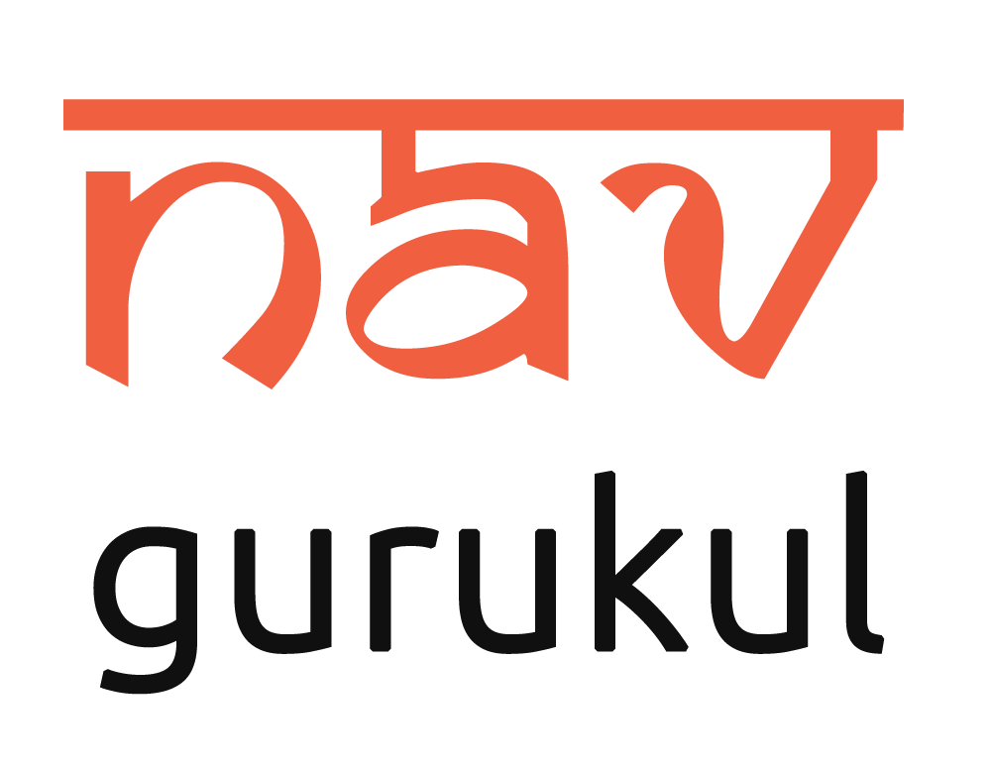 | started by an IIT-D alumnus & Entrepreneurs runs a one-year intensive course for  academically bright underprivileged students to learn programming & get high paying jobs. Students learn without a teacher & hence are self-starters and problem-solvers. You not only hire someone talented & loyal but also help in increasing workplace diversity.

