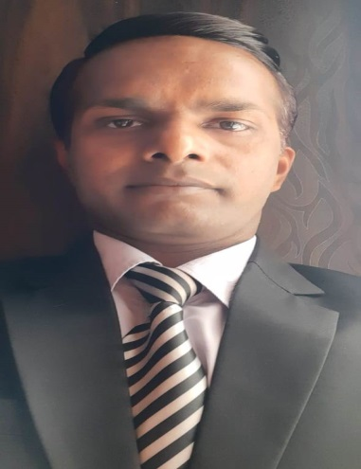

Deepak Kumar

**Summary**

Expertise in developing better customer service . Experienced with all stages of the development service operation cycle for dynamic Well-versed in numerous in service parameters and customer service .Strong background in project management and customer relations.

**Skill Highlights**

|  |  |
| --- | --- |
| * Business development * Strong decision maker * Complex problem solver | * Preferable customer service * Innovative * Service-focused |

**Experience**

* **Asst. GM (Customer service** )

Tata Grover Motors

(Authorized dealer Tata Passenger Car )

Duration -At Present –Aug-2019

* **Former Service Manager**

MADHAVA DIESELS AUTO PVT.LTD

(Authorized dealer Mahindra, Bosch ,Piaggio)

Duration – Aug-2018 To June 2019  

* **Former Asst. Works Manager**

Tata Grover Motors

(Authorized dealer Tata Passenger Car )

Duration –Feb-2017 To July -2018

* **Former Asst. DSM**

M/S Akc World Auto Pvt.Ltd.

(Authorized dealer Bajaj Passenger vehicle )

Duration –July-2012 To Jan-2017

**Education**

High School Passed From U.P Board- 1999

Intermediate Passed From U.P Board-2003

Bachelor of Art- 2014 From M.J.P Rohilkhand University

Technical Education

Diploma in Automobile engineering From NIMS -2016

Contact

**Address:**

1/11280 Subash Park Ext. Naveen Shahdara Delhi -32

**Phone:**

9068678619

**Email:**

deepakkumarkasyap357@gmail. com

Personal Details

Date of Birth : 12/09/1985

Father Name : Shri Munna Lal Kashyap

Nationality : Indian