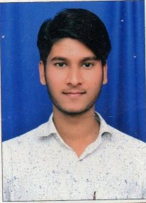 **CIRRICULUM VITAE**

**MAHENDRA KUMAR SOLANKI**

H. No. 2-A-16, Sanjay Gandhi Nagar-B

Kota (Raj.) 324007

Contact No: **7877508372,9783914158**

Email: solankimahendra057@gmail.com

**Career Objective:-**

To work in a Challenging Environment That Provides a Venue for Applying My Skill Set and Knowledge Base to Contribute to the Success and Growth of the Organization.

**Personal Details:-**

* Father Name : Dhanraj Solanki
* Date Of Birth : 21-09-1996
* Sex : Male
* Marital Status : Married
* Nationality : Indian
* Language : Hindi & English

**Education Qualification:-**

* Secondary From RBSE Ajmer in 2012 with 55.17% marks.
* Sr. Secondary From RBSE Ajmer in 2014 with 60.60%.
* B.Sc From UOK KOTA in 2018 with 45.43% marks.

**Computer Skill:-**

* Basic Computer Knowledge.
* Rs-Cit From VMOU KOTA.

**Experience:-**

* 1Year Experience of Sales man in National Medical Store.
* 1 Year Experience of Sales man in Life Style Pvt. Ltd. Kota.

**Declaration:-**

I hereby declare that the particulars furnished above are true, correct and complete to the best of my knowledge and behalf.

Date:…./…./……...

Place: ………………. **(Mahendra Kumar Solanki)**