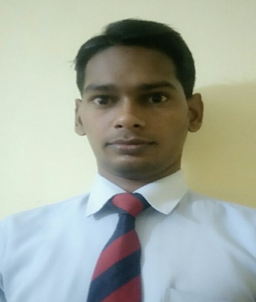 **Vishal Yadav**

**Email:** vishalyadav1508@gmail.com

**Mobile:** 7037436072

**Address:** Village Khalilabad Post Sanjarpur,

Azamgarh, Uttar Pradesh-223227

### Career Objective

To achieve an excellence in my professional and personal aspiration by being an integral part of organization with all round growth by utilizing my knowledge and skills for the achievement of desired objective and goal of the organization.

### Professional Qualification

**Degree in engineering (UTU)**

### Institute : Amrapali Institute of Technology and Sciences, Haldwani (Nainital)

**Batch :** 2013-2017

**Branch :** Electrical & Electronics Engineering

**Percentage: 62.48**%

### EducationalQualification

|  |  |  |
| --- | --- | --- |
| **Education** | **University/Board** | **Grade/Percentage** |
| B.Tech | Uttarakhand Technical University | 62.48% |
| Intermediate | U.P Board | 76.8% |
| High school | U.P Board | 62.83% |

**Training**

* One-month summer training from Mechanical Railway Workshop, Gorakhpur.

**Projects**

* Final year project on **“Smart electronics wireless based wheelchair operated by using mobile application”**

**Achievements**

* Participated in National Conference on Emerging Trends in Science & Technology (NCETST-2017) held on 29th April 2017.

### Publication

* Published the paper titled**“smart electronics wireless based wheelchair operated by using mobile application”**

URL: - <http://researchtrend.net/ijet/pdf> /126-S-886.pdf

**Experience**

* Past Worked as Mahindra auto mobiles Designation Electrical Maintainance Engineer July 2017 to 2019 Jan
* Past working T.T.P.L. Designation Site incharge Jan 2019 to Nov 2019.
* Present working Samridhi Enterprises N.M.C.G. (Project) 50 M. L.D. S.T.P. NUMAYADAHI December 2019 to appearing Designation Plant Incharge.

### IT Skills

* C, C++, MS-Office ,Embeded C, Excel

### Personal Interests

* Travelling, Reading, Writing, Internet Surfing, Sports and mindgame.

**Strengths**

* Creative, Adaptability, Determination, Leadership, Ability to work in a team

**Personal Details**

**Father’s Name: Mr**. Gorakh Nath Yadav

**Mother’s Name: Mrs**. Bijlani Devi

**Date of Birth: 22.08.1996**

**Marital Status: Married**

**Nationality: Indian**

**Languages Known:**  English & Hindi

I hereby declare that the particulars furnished above are true to the best of my knowledge and belief.

**Date:**

**Place:**

**Vishal Yadav**