H-78 HARKESH NAGAR
NEAR OKHLA METRO STATION
NEW DELHI - 110020

Mobile # 9312602560
E-mail: shyams_2001@yahoo.com
Shyam Sunder Aggarwal
FATHERS NAME  DATE OF BIRTH  ACADEMIC QUALIFICATIONS | SHRI SHANTI SWARUP  26TH NOVEMBER, 1971.  INTERMEDIATE IN COMMERCE FROM C.B.S.E.(DELHI), G.B.S.S.SCHOOL SRINIVAS PURI, NEW DELHI IN 1990  BACHELOR OF ART FROM UNIVERSITY OF DELHI (P.G.D.A.V. (E) COLLEGE) IN 1993
OTHER QUALIFICATIONS | 'OFFICE ASSISTANT COURSE' FROM BHARTIYA VIDYA BHAVAN, NEW DLEHI. THE COURSE CONSISTED OF DOS/WINDOWS/MS-WORD/MS-EXCEL/MS POWERPOINT/BASICS OF INTERNET/ PERSONALITY DEVELOPMENT & INTEGRATION WITH OFFICE ROUTINE IN 1999 (Aug. to Oct.)  ‘ACCOUNTS ASSISTANT COURSE’ FROM BHARTIYA VIDYA BHAVAN, NEW DELHI. THE COURSE CONSISTED OF “LOTUS SMARTSUITE – WORDPRO, 123 & FREELANCE GRAPHICS AND APPROACH" TALLY & E.X.NGN. IN 2000 (Feb. to May)  KNOWLEDGE OF SHORTHAND  KNOWLEDGE OF TYPEWRITING WITH SPEED 60 WPM & ABOVE
EXPERIENCE | WORKED WITH ENGINDIA RUBBERS PRIVATE LIMITED, NEW DELHI AS “ASSTT. TO MANAGING DIRECTOR” SINCE NOV.1999. AND MAY,1994 TO NOV.1999 AS AN OFFICE ASSISTANT .  SIX MONTHS EXPERIENCE IN ‘THE BANK OF RAJASTHAN LTD’ PANCHSHEEL BRANCH, NEW DELHI IN 1992-93 DURING GRADUATION.
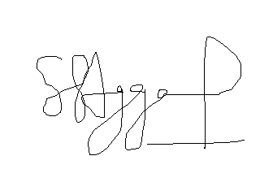  LANGUAGES KNOWN | HINDI & ENGLISH
(S S AGGARWAL)

