Mayuri potale 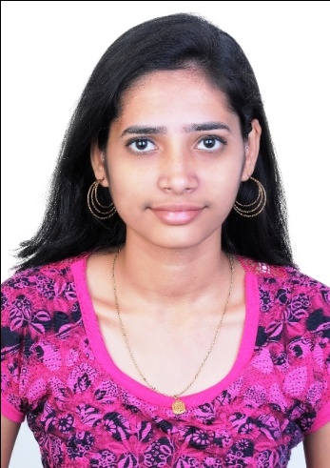

(M.com)

Phone no.9987459431

[potalemayuri@gmail.com](mailto:potalemayuri@gmail.com)

Address- room no.8, parsik co.h.sl

Sector-1, near bank of baroda

Nerul, navi mumbai-400706

SUMMARY

To Be Part Of Dynamic, Growth Oriented Organization Where Performance Is Rewarded And Have Exposure For The Development Of The Organization And Myself.

WORK EXPERIENCE

**SALES GROUP CODINATER**

HDFC BANK

My responsibilities were as follows:

Daily reports from terms

Checking all document.

Call to customers for their required documents .

Handling attendance and daily reporting .

EDUCATION

**MASTERS OF COMMERCE , 2017-2019**

UNIVERSITY OF MUMBAI

M.COM from S.I.E.S (NERUL) COLLEGE OF ARTS, SCIENCE AND COMMERCE.

**BACHELOR OF COMMERCE , 2014-2017**

UNIVERSITY OF MUMBAI

B.com from S.I.E.S (NERUL) COLLEGE OF ARTS, SCIENCE AND COMMERCE

**H.S.C, 2014**

H.S.C in FEB 2014 with 69.23% from S.I.E.S (NERUL) COLLEGE OF ARTS, SCIENCE AND COMMERCE.

KNOWLEDGE & SKILLS:

* Have intermediate level knowledge of **Microsoft office** **package tools** i.e. Excel, Word, PowerPoint etc.
* Have basic knowledge about **Adobe Photoshop** and other editing tools
* Have good **commutation skills**, and positive attitude for solve problems.

ACHIEVEMENTS

National level and state level Achievements

* Selected for 800m and 1500m race for represent Maharashtra in National Athletics Meets (2013-2014)
* 1st in state crosscuntry race .(2015)
* 1st in 800m race and 2ed in 1500 race in Maharashtra state level sports athletics meet(2013)
* 2ed in BOMBAY YMCA SPRTS ATHLETICS MEET in 800m.
* Won Title of NEW MUMBAI ATHLETICS CHAMPIONSHIP. (2010-11)
* Won more than 60 running compactions. (2009-2015)
* Participated in national level cross-country race.(2011)

UNIVERSITY and College level compactions

* 3ed in 800m race in MUMBAI UNIVERSITY Sports Meet.(2016)
* 3 ed rank of football term in MUMBAI UNIVERSITY Sports Meet.(2016)
* 2ed in Dress Designing compaction in inter-college fest.(2014)
* 1st  in 400m,800m,1500m race in intra college spots meet.
* 1st 5 km marathon organized by KARMVIR BHAUROI PATIL COLLEGE .(2014)
* 1st 5 km marathon organized by STALING COLLEGE, NERUL .(2013)
* 1st 5 km marathon organized by STALING COLLEGE, NERUL .(2014)
* Won BEST SPORT PERSON TITEL in college .(2015-2016)
* Won more than 20 college level sport meet,
* Participated more then 25 college level sport meet .