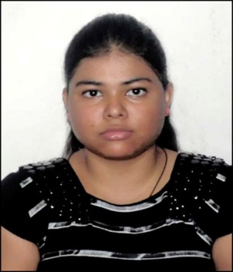

Varsana Pathak

Gender: Female

Date of Birth: 26 November, 1992

Nationality: Indian

Marital status: Single

**Contact address**

Asvini Anjali Apartment

Flat No.A003, No.2 Madgharia

Noonmati Guwahati-781020, Assam, India

Email-ID: varsanapathak@gmail.com

Phone: +91-9401593014, +91-6900186718

**Academic details**

|  |  |  |  |
| --- | --- | --- | --- |
| **Qualifying Exam** | **Institute/University** | **Year of passing** | **CGPA/Percentage/Rank** |
| Diploma in Computer application | nECT | 2017 | 1. Grade ( 60-79%) |
| Master of Science (M.Sc. in Statistics) | Dept. of Statistics,, Gauhati University, Guwahati, India | 2017 | 8.45/10 (1st Class & 2nd Rank) |
| Bachelor of Science (B.Sc. in Statistics) | Handique Girls’ College,Guwahati,  India | 2015 | 8.2/10 (1st Class with Distinction) |
| Higher Secondary  (12th) | Cotton College, Guwahati,India,  (AHSEC) | 2011 | 71 % (1st Division) |
| Matriculation  (10th) | Glacier School, Guwahati,  India(SEBA) | 2009 | 80.7% ( 1st Division) |

**Technical skills**

* **MS Office**
* **MS Excel**
* **R programming**
* **C language**
* **Basics of SPSS**
* **Basics of Python**

**Academic programs/Workshops/Internships**

**A Workshop on Statistical Data Analysis using Open Source Platform (2017)**

* Attended a One-day Workshop on Statistical Data Analysis using open source platform.

National Science Day Celebration (2017)

* Participated in the event of Model exhibition: Science for the betterment of life.

Academic Field Survey (2013)

* Participated in one day Academic Field Survey in Morigaon town of Assam.

**Achievements**

* Qualified P.G.Diploma in Statistical Methods and Analytics(ISI) in 2015.
* Qualified Master in Population Studies(IIPS) in 2017.

**Strengths, Interests, Hobbies**

* Positive attitude, Determination, Hard working, Open-minded
* Running, Dancing, Travelling, Reading Books, Adventure Sports,Cooking.

**EXTRA – CURRICULAR ACTIVITIES:**

Learning Sattriya Nritya, Indian Classical dance ; (Present)

**Motivation letter**

I can work on different tools like MS Excel, R programming and different R packages, SPSS etc. As I am from a field of Applied Science I solely want to work in a field where I am able to apply my knowledge of data analysis and not only application but I will also be able to learn new techniques of analyzing data .

I have good interaction and communication skill and I think that this quality of mine will be of great help for this position. I have the experience of working in groups and so I have good team work spirit. I am highly passionate about what I really like to do and I can devote my true dedication to the things I enjoy doing from my heart. I am very dedicative towards my work and which I think is very essential for a researcher. I am an open minded person and I always like to make friends. I believe that true perseverance and hard working are the key to success and not only the key to success but also the true essence of life. I keep a positive attitude towards life and I believe that a positive thought is way more powerful than a negative thought and that people can change their life through their positive perspective.