
Sales and Marketing/Business Development/ Trade Management/P&L Enhancement
VARUN KULSHRESTHA

Goal-oriented professional with proven record of achievement in conceiving & implementing ideas that have fuelled market presence and driven revenue / profitability; targeting senior-level assignments with an organisation of repute

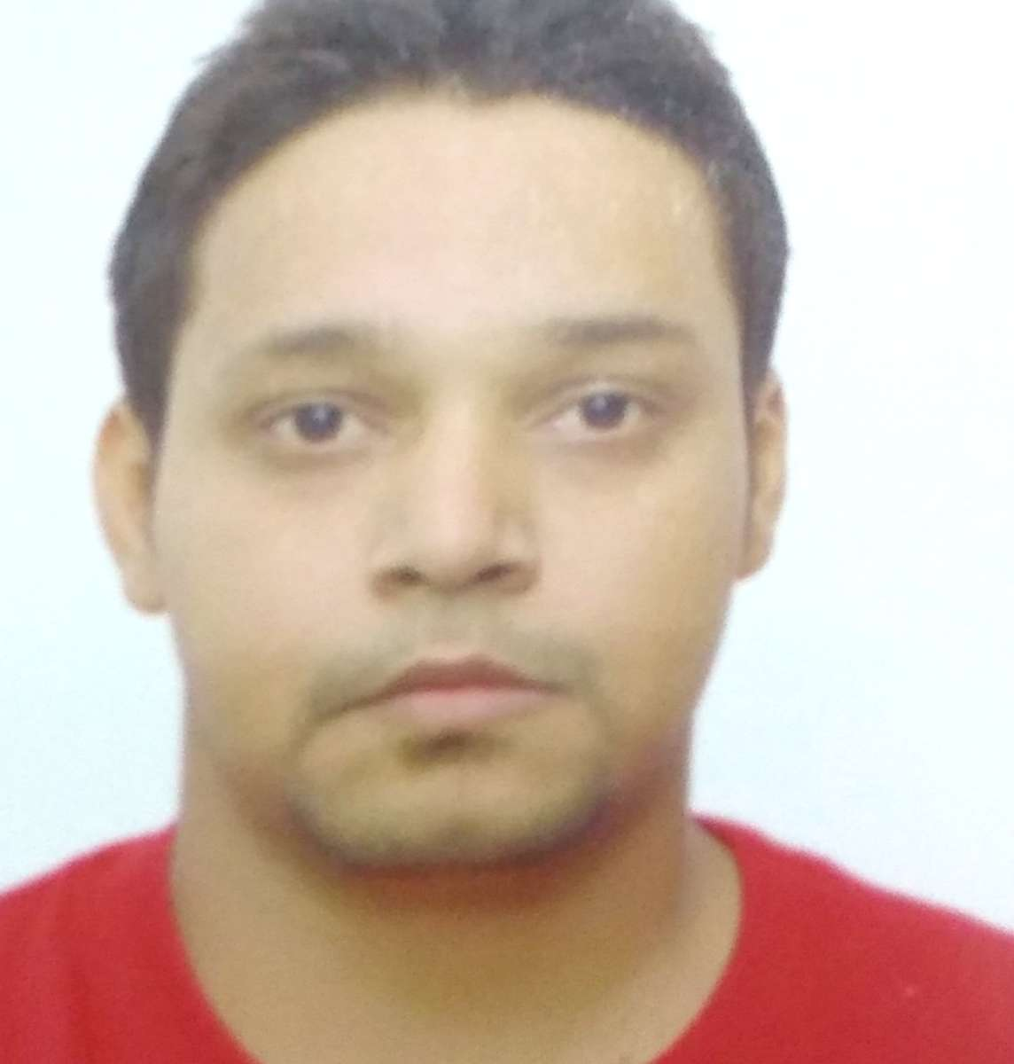
Career Summary  - Focused professional with over 07 years of rich experience in Strategic Planning, Sales & Marketing, Channel & Dealership Management  - Planned, formulated and implemented marketing strategies and promotions to increase market penetration and to drive revenue and profitability by maximizing sales  - Accomplished and exceeded volume and profit goals by nurturing partnerships with existing customers  - Impacted organisation profitability through effective strategic and tactical management decisions and new business development  - Led innovation and optimization across channels to continuously improve/enhance company offerings and customer experiences  - Leveraged skills in designing, implementing and monitoring strategically focused sales plans for creating advantage to both the company and business partners  - Facilitated business planning & performance management of channel/distribution partners including development & execution of joint sales plans, local area marketing, staff coaching, recruitment & hosting constructive meetings  - Supervised sales and marketing manpower as well as the hiring and training of personnel  Education & Credentials  - MBA (Marketing&HR) from Inderprastha Engineering College, Ghaziabad UPTU in 2014  - BBA from Jamia Hamdard University in 2011  - Diploma in Complete Business Accountant (C.B.A) in 2008  Certification  C  - IRDA License  IT Skills  - Operating Systems: Windows XP  - Packages: Microsoft Office, Well versed with Internet and PowerPoint | Contact  varun01.kulshrestha@gmail.com  +91-9953900262  Core Competencies  Strategy Planning & Implementation  New Product Launches  New Business Development  Channel Management  Dealership Management  Competitor & Market Analysis  Strategic Partnerships & Alliances  Team Management  Client Relationship Management  Soft Skills  Motivator  Communicator  Change Agent  Collaborator  Analytical  Leader
Professional Experience

Since Sep’14 with Bharti Airtel Ltd. as Customer Relationship Officer

Key Result Areas:
- Spearheading profit centre operations of sales & marketing with focus on volume, profit & revenue growth; preparing and aligning annual budget/ area sales targets to the country & regional objectives
- Formulating long-term & short-term strategic plans, forecasting future business possibilities in existing and new markets with potential growth possibilities
- Devising and implementing profitable business acquisition programs with customers, engaging the employees, monitoring progress and evaluating benefit
- Acting as the Central Point of Contact for the customer, ensuring the strategy is fully implemented and customer is well serviced
- Liaising with corporate contacts, building & sustaining relations with customers; categorizing all the official/ unofficial information, channelizing the same, deploying them in action plans and strategies
- Justifying new product development investments, determining and documenting new product requirements
- Reviewing product pricing & gross margin goals for existing products and establishing new product pricing
- Contributing in retaining and increasing key accounts; displaying credentials in maintaining relations with priority customers and markets, jointly working for generation of global enquiries, price negotiations, business awards, timely development of new programmes & launches
- Establishing the sales targets marketwise, strategizing to achieve the sales target and implementing the action plan to achieve the sales numbers
- Planning for enhancing brand image, acceptability and positioning, resulting in increased sales and consistent growth in business opportunities
- Achieving relevant market share and enlarging product value as per the corporate plan

Previous Experience

Jul’14 –Sep’14with HDFC Bank as Branch Sales Officer

Key Result Areas:
- Accomplished the allocated sales targets within the strict timeframe for an assigned territory
- Developed strategies to enhance customer relations through formal and informal channels, building cordial relationship through regular interactions & apprising them with institute’s value propositions
- Managed business development activities entailing mapping of new market segments and developed the assigned areas for the attainment of periodical targets

MM’11-MM’13 with Kotak Mahindra Life Insurance Agency as Life Advisor

Key Result Areas:
- Presented firm to customers and explained objectives and benefits of various insurance programs
- Assessed clients’ requirements and recommended policies as per their needs and budget
- Analysed existing insurance policies and explained details of amount to the insured

Summer Internship

Organization: SM Elemech & Engg Pvt Ltd (Marketing)
Duration: one month


Personal Details
Date of Birth: 01st Jul 1989
Languages Known: English & Hindi
Address: B-234, First Floor F-2 Ramprastha Ghaziabad, (U.P), Pin code- 201011

