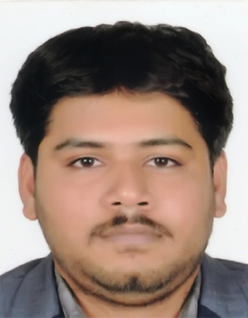

**CURRICULUM VITAE**

**A. RAMKUMAR**

**EMAIL ID:** sramk.786@gmail.com

**MOBILE:918248104891**

**CAREER OBJECTIVE:**

To have a growth oriented and challenging career, where I can contribute my knowledge and skills to the organization and enhance my experience through continuous learning and teamwork.

**ACADEMIC QUALIFICATION:**

|  |  |  |  |  |
| --- | --- | --- | --- | --- |
| **Course** | **University Board** | **Institute** | **Year of passing** | **Percentage CGPA** |
| Bachelor of Mechanical Engineering | Anna University | Dhanalakshmi Srinivasan Engineering College | 2014 | 73.3% |
| Higher Secondary | State Board | E.R. Higher Secondary School Trichy | 2010 | 76% |
| SSLC | State Board | E.R. Higher Secondary School Trichy | 2008 | 79% |

**PERSONAL PROFILE**

Date of Birth **:** 19.07.1993

Gender : Male

Marital status **:** Single

Languages Known **:** English and Tamil

Permanent Address  **:** 4/10A, Velayuthapuram, South Street, Lalgudi, Trichy-621218

Country : INDIA

**WORK EXPERIENCE:**

1. **SRI ARN motors private** LTD,**.-**Thanjavur. (from FEB 2015 to MARCH 2016)

**APPRENTICE JOB TRAINING IN** (Service And sales sectors)

1. **SRI ARN MOTORS** Pvt Ltd**,-** Irungallur( Trichy-DT) (from MARCH 2016 upto JUNE 2018) **Working** As **workshop floor supervisor engineer in automobile sector.**
2. Currently working in automobile industry in trichy from july 2018 to upto now.

.

**IELTS EXAM :**

I Took **INTERNATIONAL ENGLISH LANGUAGE TESTING SYSTEM (IELTS)** Overall Band Score 6.5 Band On 18.8.2018

|  |  |  |  |
| --- | --- | --- | --- |
| LISTENING-7.0 | READING-5.5 | WRITING-5.5 | SPEAKING-7.0 |

**TECHNICAL AND MANAGERIAL SKILLS:**

* Auto Cad, SolidWorks, Ansys, Catia v5, Automation Studio.
* Six sigma , knowledge of SAP.

Currently doing training course NEBOSH IGC and IOSH in Trichy.

**AREA OF INTEREST:**

* Supply chain & Logistics ( Import and Export field)
* Automobile.
* Engineering management
* Oil ,gas, fire and safety engineer

**EXTRA CURRICULAR ACTIVITY:** Basically I am a sports enthusiast. I was involved in various athletic events including long jump,high jump and pole vault and shot put, javelin. I have represented the college and school in these activities and have participated for several years in the cricket.

I hereby declare that all the details furnished here are true to the best of my knowledge.

**DATE** **: 12.03.2020 SINCERELY PLACE: TRICHY**  A RAMKUMAR