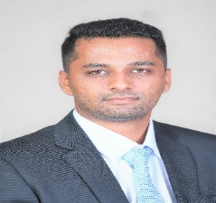

**Vivek Singh**

DOB: 27/06/1994

Mobile No: +91-8766978948| Email: [vivek.singh21@bimtech.ac.in](mailto:vivek.singh21@bimtech.ac.in),

LinkedIn: https://www.linkedin.com/in/vivek-singh-b7a52a106

**ACADEMIC PROFILE**

|  |  |  |  |  |
| --- | --- | --- | --- | --- |
| **Year of passing** | **Course** | **Specialization** | **College/University** | **CGPA / %** |
| 2021 | PGDM(IB) | Finance | BIMTECH College, Greater Noida | 7.71 CGPA |
| 2017 | B.Tech | Electronics | Bharati Vidyapeeth College of Engineering Pune | 61% |
| 2012 | 12th | Science (PCM) | Lucknow Public School (U.P.) | 64% |
| 2010 | 10th | General | Bhavan’s Prominent School, Indore (M.P.) | 8.8 CGPA |

**PROFESSIONAL EXPERIENCE**

|  |  |  |  |
| --- | --- | --- | --- |
| **Assistant Java Developer (Intern)** | | **Mind Script, Pune** | **September 17-March 2018** |
| **Roles & Responsibilities** | **Project Title**: UI developer (JAVA)   * Worked as an interface developer. * Database Management of various sites. | | |
| **Achievements** | * Acquired time-management skills. * Enhanced inter-personal skills. * Good knowledge of working on MS-Excel. | | |

**PROFESSIONAL QUALIFICATIONS & CERTIFICATIONS**

|  |  |  |
| --- | --- | --- |
| **Year** | **Certification** | **Institute** |
| 2020 | Complete Python Bootcamp From Zero to hero | Udemy |
| 2020 | Private Equity and Venture Capital | Coursera |
| 2020 | Excel Skills for Business: Intermediate 1 | Coursera |
| 2020 | Financial Modeling: Build a Complete DCF Model | Udemy |
| 2020 | The Complete Financial Analyst Training and Investing Course | Udemy |

**POSITION OF RESPONSIBILITY**

|  |
| --- |
| * Co-ordinated marketing team in college fest Bhartiyam during 2015-17. * Member and host of Health Club in school during 2011-12. * Vice-Captain of Bhavans Prominent School during 2009-10. |

**ACHIEVEMENTS & ACTIVITIES**

|  |  |
| --- | --- |
| **Extra – Curricular** | * Won in Dare2Compete (Finanza- The Rupee Matters 2020) * Secured 2nd Position at OmniGlotzz Infographic competition in 2019 * Won many prizes in various tournaments of badminton, cricket and 100-meter race held at Inter house and inter school level. * Silver medalist in roller skating competition organized by Taj group (Agra division) in 2012. |

**HOBBIES AND INTEREST**

* Playing Badminton & Cricket.