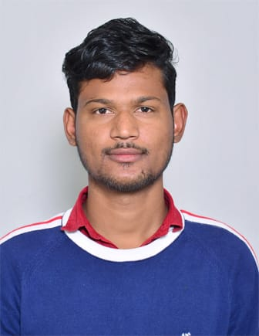  Mohammad Nadeem  CONTACT INFORMATION : Address: Krishna nagar mandi samiti pokhrayan Kanpur dehat  Contact No: 8542925508  Email: mnadeem8542@gmail.com PERSONAL DETAILS:  Date Of Birth : 15/07/1997  Sex : Male  Marital Status: Unmarried  Nationality:  Indian  Father’s name:  Mr.Nafees  Mother’s Name:  Mrs. Gudiya | CURRICULUM-VITAE  CAREER OBJECTIVE  - To work in an organization that provides me with an opportunity to grow and learn and help me to achieve my personal as well as organizational goals.  PROFESSIONAL QUALIFICATION  - Bachelor of technology with computer science specialization from  Kanpur institute of technology affiliated with aktu  ACADEMIC QUALIFICATION  KEYSKILLS AND ATTRIBUTES  WORK EXPERIENCE  - Being fresher I don’t have any work experience.
  Examination Board/University School/College Year of passing
  Bachelor of Aktu K.I.T kanpur 2021
  Technology
  Intermediate U.P Board R.S.G.U inter college 2015
  High School U.P Board R.S.G.U inter college 2013
  Key Skills | Key Competencies
  - Spend less ,do more  - Influencing and negotiation  - Team playing  - Creativity and expression  - Problem solving  - Decision making  - Ambition to succeed | Software: MS-office 2007,2010  Operating system: windows-7,8,10
Technical skills

- Python
- Microsoft Excel
- Communication

HOBBIES & INTERESTS
- Traveling
- Gaming
- Singing

DECLARTION
I hereby declare that the information furnished above is true to the best of my knowledge.

Place : Kanpur ___________________
Date : (Signature)
(MOHAMMAD NADEEM)

