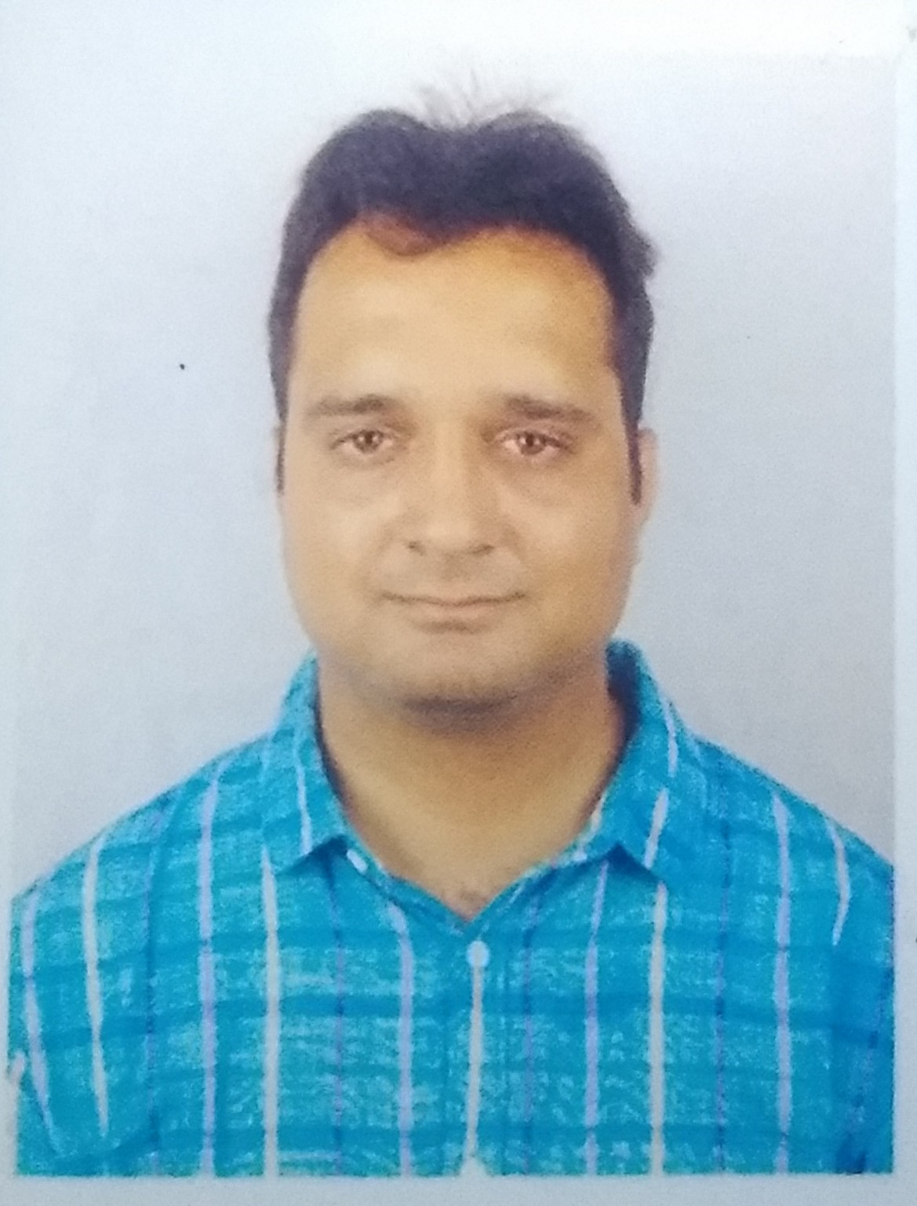
Jatin N. Pathak ( B.Tech. Petroleum Engg )
Contact : +919408507814 , +918402044160
Email Id: jatin191290@yahoo.com,
SENIOR ENGINEER PROJECTS
9+ yrs, Oil and Gas/Petrochemical/Refineries Industry

Profile Summary

Petroleum Engineer ( B.Tech,Petro.Engg ) with 9 yrs consistent experience in construction of Mega petrochemical complexes and refineries and project management in Oil & Gas Industry. I have complete expertise and managerial skill to handle independently any small or mega project construction works Abreast with International Pipeline Codes & Standards, Procedures, Standards & Laws applicable to Engineering, Construction and Maintenance of Pipelines. Skilled at managing project billing & planning and establishing efficient HSE awareness activities on sites. Possesses comprehensive knowledge of assorted piping materials like GI, Stainless Steel, Alloy Steel, Carbon Steel, Low Temperature Carbon Steel, etc.
Currently I am executing Visakh Refinery Modernisation Project (VRMP) which is a brownfield expansion of the Hindustan Petroleum Corporation Limited Visakhapatanam Refinery located in Visakhapatnam, India. Designing of flaregas system , manufacturing of the system including piping mechanism and then installation on site, is within contract with our company. I am leading entire project at refinery site since Jun-2018. ( https://www.hydrocarbons-technology.com/projects/visakh-refinery-modernisation-project-visakhapatnam/

Skill Expertise

- Project Procurement & Cost Estimation
- Project Execution & Quality Assurance
- Site Activities Execution & Maintenance
- Mechanical Design Drawings Preparation
- Materials & Corrosion Engineering
- Operations Planning & Management
- Onshore Pipeline Design Projects
- Cash Flow and Fund Management
- ISO and P&ID Reading & Review
- Optimal Resource Management
- Managerial and Interpersonal Skills
- Analytical and Problem Solving Skill

Professional Experience

Airoil Flaregas Pvt Ltd,Mumbai,India Jun 2018 till Date
( https://www.airoilflaregas.com/ )
Senior Engineer Projects

The company offers complete design, engineering, manufacturing, installation and commissioning services for flare systems across the hydrocarbon sector.
Present responsibility includes
- Project management and execution at site for ‘Demountable Flare systems at ( Guru Govind Singh Refinery (GGSR) Bathinda. Client - HPCL-Mittal Energy Limited (HMEL)( http://www.hmel.in/ ) , a joint venture between Hindustan Petroleum Corporation Limited (HPCL) and Mittal Energy Investment Pte Ltd, Singapore.
- Visakh Refinery Modernisation Project (VRMP) is a brownfield expansion of the Hindustan Petroleum Corporation Limited Visakhapatanam Refinery located in Visakhapatnam, India. Designing of flaregas system , manufacturing of the system including piping mechanism and then installation on site, is within contract with our company. I am leading entire project at refinery site. The project is being executed. ( https://www.hydrocarbons-technology.com/projects/visakh-refinery-modernisation-project-visakhapatnam/ )

Ardhinusa Drilling Pvt Ltd,Ahmedabad,India Feb 2016 to Jun 2018
( a sister concern of Jaihind Projects Limited.)
Senior Engineer Projects

Projects :---
- IOCL’s - Ganga River HDD Project - 1980meters crossing Patna Hathidah Station - HO Ahmedabad
- IOCL’s – Re-alignment of 16” KRPL across Panam River by HDD method - 850meters - Devgarh Bariya
Location: HO Ahmedabad and at site

Projects Responsibilities :---
- Maintaining proper coordination and flow of information between the client and management of site & HO to avoid miscommunication
- Maintaining correspondences and attending various progress review meetings with client
- Submitting various Work Procedures, Drawings and Design Calculations as per the standards and safety requirements of the client for the execution of the work up to client’s satisfaction
- Managing procurement of various items (contractor supplied/ consumable), and item specific professional services
- Managing the weekly cash flow requirements for site activities
- Keeping track of the equipment & tools required at site so as to ensure the availability
- Analyzing quotes if various vendors for various supply & service activities and releasing purchase/ work orders
- Maintaining billing activities as per the terms of the contract to keep the fund rotation of the company
- Making various reports like equipment requirements, billing details and costing of various activities
- Ensuring floating inquiries for various items as per the costing for various items and services for the profitability of the project
Other Deliverables :---
- Ensuring the compliance of International Design Guidelines, Codes and Standards
- Assisting in estimating the mechanical quantum of works for pipeline and piping materials
- Analyzing the budgetary quotes of various vendors towards making a successful bid
- Keeping track and list of various upcoming projects & tenders and their deadlines to manage design budgets
- Assisting in the ongoing projects with technical purview and knowhow.

Jaihind Project Ltd., Ahmedabad (HO) Oct 2015 - Jan 2016
Senior Engineer Projects
- Preparation and submission of final bill of completed project at Dibrugarh during last three years.

Jaihind Project Ltd., Dibrugarh Aug 2012 - Sep 2015
Site Engineer (Piping Division - ECU-1 Unit)

Project Description :---
Mechanical works for the piping and pipeline facilities for the Rs.10000 Cr. Petrochemical Project floated by the government of India in the joint venture company "Brahmaputra Cracker & Polymer Limited” (www.bcplonline.co.in/) for the construction of a mega gas cracker petrochemical complex near Dibrugarh town, Assam. Process Flow Diagram - Gas Sweatening Unit - Ethylene Cracking Units I & II – Output plants (Polypropylene & LLDPE).

Project Responsibilities :---
- Managing the site activities by maintaining the execution of mechanical works
- Handing piping, erection, grouting, alignment, hydrostatic testing of piping & equipment, fabrication, blasting and painting
- Coordinating with difference verticals of the mechanical works like billing, store and materials, QA/QC and execution persons in the team to achieve envisaged tasks
- Devising efficient solutions to construct problems & difficulties arising due to discrepancies in design or material incompatibility
- Maintaining availability for loops and systems for ramping the mechanical clearance of the site
- Attending punch points from the clients to achieve site completion of the pre-commissioning activities
- Ensuring checking and mechanical clearance of loops by the client
- Preparing field-test reports (FTR’s) and liaising with construction and pre-commissioning personnel to ensure correct completion
- Handling Material and FIM availability management for the smooth parallel and transitioning between activities.

IT Skills
- AutoCAD, C++, Solid Edge/ Solid Works and AutoDESK Navisworks Freedom
- MS Project Planning MS Office (Word, Excel & PowerPoint)

Academic Credentials
- B.Tech. Petroleum Engineering, School of Petroleum Technology, Pandit Deendayal Petroleum University, Gandhinagar (Gujarat) in May 2012 (www.pdpu.ac.in)

Courses
Three months certificate course on Piping Engineering.
Organization: Indian Institute of Technology, Bombay
( Aug to Nov, 2015 )

Trainings
Course on Offshore Drilling Operations (6 to 10, February 2012)
Organization: PetroSkills

Time Cycle Reduction for Domestic Connections and Complaints Handling (6 Weeks)
Organization: Adani Gas Ltd., Ahmedabad (Industrial Training)

Oil Field Training for Acquaintance Practices Being Adopted for Development & Exploitation of Hydrocarbon in Light and Heavy Oil Fields of Mehsana Asset (6 Weeks)
Organization: ONGC, Mehsana (Industrial Training)

Project included improving sanitation practices in the villages covered by the organization
Organization: Lokvikas Sanstha, Tapi (Rural Training)

Project Work
- Completed project on Application of Neural Network Technique in Evaluating Reservoir Parameters for Resource/Reserve Estimation

Personal Details

Date of Birth December 19, 1990, Unmarried, Ht. 168 CM. , Wt 65 Kg
Address A-11, Akshar Bungalows, Opposite NID, Near Hotel Middle Town ,
Behind Radhe Sweets, Kudasan, Gandhinagar, Gujarat, Pin Code-382421
Languages English, Hindi, Gujarati and Assamese
Passport Number K4233614 (Valid up to 12-04-2022) Issued from Ahmedabad, India.
Interests Football and movies.

Reference

Mr. M. K. Taunk,  AGM, Engineers India Limited ( EIL )  +91 9531035059  mechatataunk@gmail.com | Project Site  Brahmaputra Crackers and Polymers  Limited, Dibrugarh , Assam , India,  www.bcplonline.co.in/  (Construction Rs. 10000 Cr. mega gas cracker petrochemical complex near Dibrugarh )

Jatin Pathak

