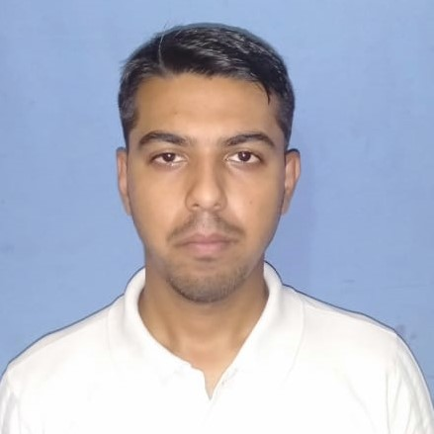

|  |  |  |  |
| --- | --- | --- | --- |
| **DULAL GHOSH** |  |  | **Email – dulalghosh99999@gmail.com** |
| **Deputy Manager** |  |  | **Phone – 8794403307/7005376249** |
|  |  |  | **Address -Agartala,799004** |
|  |  |  |  |

**PROFESSIONAL SUMMARY**

**Five years and one month** of experience in **Accounts, Banking operations, Business Development & Customer Relationship**. Presently working as a Deputy Manager in Axis Bank Ltd**.** Smart worker with proven abilities in accelerating operational domain with precision. Proficient in implementing effective actions. Possess excellent interpersonal and communication skills.

**OPERATIONAL ACTIVITIES**

* Authorization of all banking transactions like Cash/DD/PO/RTGS/NEFT/IMPS etc.
* Processing of AOF after verification of KYC with due diligence.
* Control on stock of security items in hand
* Reconciliation of office Account.
* Maintenance of relevant registers/vouchers/folder.
* Minimizing Operational errors / Prevention of frauds as per circular and operations manual guidelines.
* Preparing monthly expense reports, GL reports and various other half yearly and annual reports. Cash reports.

**Adherence to Policy & Process**

* Ensure there are no circular transactions between customers account as per AML Policy
* Ensure transactions are passed as per authority delegated.
* Delivering superior client experience in the lobby by rendering exemplary levels of customer service thereby making banking simple and hassle free for the customer.
* Rectification of internal and external audit query.
* Maintenance of daily/weekly/monthly branch records and adhered to statutory guidelines and compliance for better realization and discipline.

## WORK EXPERIENCE

1. **Customer Service Officer**

**ICICI Bank Ltd**

July 2015 to Sep 2019

**2.Deputy Manager**

Axis Bank Ltd

Sep 2019 to12thoct 2020

**Job Responsibilities**:

* Keep an eyeball on overall Branch transactions including Cash, RTGS etc relevant to Compliance and procedure.
* Lobby Management and handling Escalated Customer complaints.
* Operations- Handling of query of EDD cheques for preferred customers.
* Profitability Analysis - Cross sales to walk-in customers to boost the branch's profitability.
* Reports Analysis-BOD, EOD, ISRA, Deliverables, Ikit etc.
* Resolution Activity-Addressing various complaints escalated from the front end team by MILAP and resolving them at with in TAT.
* Take care of branch profitability and smooth functioning.

**PROFESSIONAL / EDUCATIONAL QUALIFICATIONS**

PGDBO Banking and Finance (2014-2015) INSTITUTE OF FINANCE BANKING AND

INSURANCE (82%)

Bachelor of Commerce (2011-2014) BIR BIKRAM MEMORIAL COLLEGE

(52%)

XII – TBSE (2011) NETAJI SUBHASH VIDYANIKETAN

TBSE Board (60%)

X – TBSE(2009) SUBHASH NAGAR H.S (+2) SCHOOL

TBSE Board (54%)

Business Computer Application,

Business Accounting,Tally ERP & PF/ESI, The Institute of Computer Accountant Business Communication

(Grade B)

**ACHIEVEMENTS:-**

**From ICICI**

Qualified contest of LI ZCDP for May-June,2018

Qualified contest of SUPERSTARS SUMMIT (In recognition of exemplary performance in ERV business for FY 2018)

Qualified contest of LI ZCDP Goa for August and September (2018)

Achieved Delightful Dhamaka Contest for the month of February, 2017

Achieved LI ZCDP Vizag for the Mid year of 2017

**From Axis**

Achieved LI September to Remember contest

Achieved maximize Power (Unlesh LI Power)

**STRENGTHS**

* Strong analytical skills coupled with commitment to excellence and ability to drive performance in cross cultural, fast paced and time sensitive environment
* Proven success in multiple Finance domains
* Process driven
* High on People management Skills

**Personal Profile**

Name : DULAL GHOSH

Date of Birth : 14-12-1992

Marital Status : Unmarried

Permanent Address : : C/O AJIT CHANDRA GHOSH

VILL:-SUBHASNAGAR, P.O-

EAST PRATAPGARH. P.S-EAST

AGARTALA, PIN CODE-799004

The Details provided above are true to the Best of my knowledge.

Place : Agartala