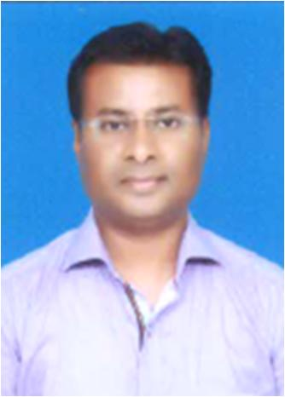**Kamlesh Shrikumar Gedam**

H-482, Bilt Paper Mill Colony, Ballarpur

PO: Ballarpur, Dist: Chandrapur (MS)-442901.  
Email: kam91221@gmail.com  
Cell: 8999084406, 7507355026

**Objective Career**

Seeking Administrator and Secretarial position where my excellent communication skills, computer knowledge and organizational abilities that will be helpful in contribute to the development of the organization with impressive performance.

**Professional Experience of 22 yrs.**

* 7 years of experience as a Personal Assistant of Unit Head with proven track record of successfully managed & complete the given tasks and meet the requirements systematically on time.
* 15 years of experience in Admin department to providing full administrative support by utilizing superior organizational and planning skills.
* Responsible for administrative and clerical activities of Administration department of the company such as liaison with local bodies & Govt. officials.
* Responsible for implement work processes to develop efficiency, manage organized events and functions and deal with clients at all levels.
* Experience of making Travel Plan, Booking Air Tickets / Train tickets and guest House & Hotels arrangements, Passport related issues etc.
* Organizing Meetings, Scheduling Appointments, Arranging Video conference and Presentations.
* Responsible to resolve problems by problem- solving and decision making tactics.
* Experience of organizing and hosting all Cultural and Sports activities.

**Computer Skills**

* Expertise in computer knowledge and skills in Microsoft office, Microsoft Excel, Microsoft Outlook and Microsoft PowerPoint etc.
* Excellent typing skill, (can type 60 wpm), Letter drafting, Translation, PPT presentations & Data management in Excel.

**Keys and Strengths**

* Good presentation and organization skills.
* Self-motivated.
* Good knowledge of PA, Admin & clerical work.
* Good communication skill.
* Excellent multi tasking skill.

**Academic Qualification**

**Central India Institute of Management Studies**

Graduate Diploma in Management Studies – A Grade

**Sardar Patel College of Art, Commerce & Science**

HSSC – B Grade

**Thapar High Secondary School, Ballarpur**

SSC – B Grade

**Personal Details**

**Date of Birth** : 31st Jan. 1976  
**Languages** : Marathi, Hindi & English   
**Nationality** : Indian

**Marital Status** : Married

**Current CTC**  : 3.96 lacs + Accommodation with Electricity & Water + Medical Facility &

Medical Insurance for family.

Place : Ballarpur **Kamlesh S. Gedam**

Date : 31st Dec. 2019