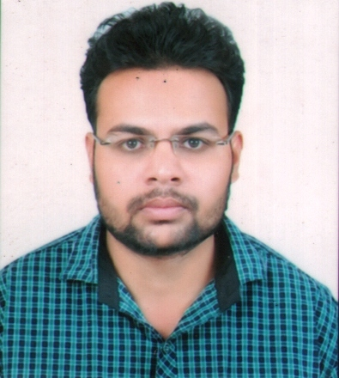
CURRICULUM VITAE

Gaurav Rathore
Address: - E-674 Shabri Nagar Bhanpur Bhopal (M.P.)
Email Id- rathoregourav626@gmail.com
Mob: +91-8109387897, Whatsapp :- 8109387897

CAREER OBJECTIVE

- To get an Expertise in Procedures of Professionally Managed Progressive Organization and see to Continuous Value Enhancement and Knowledge gain.
ACADEMIC QUALIFICATION

- MBA (Pursuing) from Barkatullah University Bhopal. (Last Sem exam given through Open Book System) Last Sem exam result awaited, All three Sem are cleared (all III Sem aggregate is 68%)
- B.SC. with (MDCS) from M.V.M. Collage Bhopal. (65.10%)
- I.T.I. Completed in tractor mechanic trade (NCVT) from Model I.T.I. Govindpura Bhopal.
- 10+2th standard completed from MP Board With 69.8% , Year of Passing- 2009
- 10th standard completed from MP Board With 72% , Year of Passing- 2007

Work Experience
- 3year and 8 months experience in Aegis BPO as a CCE and 06 month experience as a team leader.
- 01 year experience as a personal assistance of People’s mall Executive Director.
- At present work in Manjula K. Ponda College of Management as a D.T.P. Operator & office Assistant since October 2015 to till date.

Responsibility in Present Job
- Preparation of data of letter typing students related to all types of computers given in the office and to do all kinds of computer related tasks.
- Registering & reporting all students at the time of admission and preparing their set of documents.
- Filling up all forms related to Scholarship.
- Filling all forms related to Enrollment & Eligibility.
- All type work of conducting university exam.
- Typing English and Hindi.

SKILLS

- Excellent communication skill.
- Good Interpersonal skill.
- Good computer works skill.
- Good Knowledge of Government projects approvals.

COMPUTER KNOWLEDGE

- Best Knowledge in – M.S.Office.
- 1 year DCA diploma from Nice Tec University (C.G.)
- Additional Six month DCA from STAR Microsoft Computer Institute in Bhopal.

PERSONAL DATA
Father’s Name | Mr. Tejkaran Rathore
Date of Birth | 26th April 1992
Marital Status | Married
Strength | Positive Attitude, Quick Learner, Hard worker
Hobbies | Playing Cricket, Listening songs and Watching Inspirational Movies
Language | Hindi (Read,Write,Speak)  English (Read, Write)

DECLARATION
I hereby declare that the information furnished above is true to best of my knowledge.

DATE: 01/01/2021
PLACE: Bhopal

Gaurav Rathore

