###  +918369531487

→ [trupti.dhond2000@gmail.com](mailto:trupti.dhond2000@gmail.com)

 Maharashtra, Mumbai

Trupti Dhond

BMS department student

# PROFESSIONAL GOALS

Secure a responsible career opportunity to fully utilize my training and skills, while making a significant contribution to the success of the company.

# KEY SKILLS

**Social Media Marketing**

**SEO, SEM, Digital Marketing, Brand Management , Sales , Public Relations Tally ERP 9 with GST, Advance EXCEL, MSCIT**

**Internships**

**SOCIAL MEDIA MARKETER intern** Dec '20

**Pie Rooms.com**

Assists the department head in carrying out digital marketing campaigns

Works closely with the marketing head for digital promotions and other materials

Interacting with customers and enhancing them in the various contest and quiz through online

Mumbai, WFH

**Service Provider** Feb '21

**AM Technique. | 2020-2021**

Making pancard and various services online Social Media marketing

Designed the company's online tech page

**Campus Ambassador** May '21 - Present

## VIRAL FISSION

Networking with new brands and leads Working with various brands

coordinationTeam co-ordination and task completiton

Mumbai

**ACADEMIC HISTORY**

**Bachelors of business management studies | Marketing** Jun '17 - May '21

## Thakur College Of Science And Commerce

Participated in various events and team leader in various events.

last sem results yet not declared

Mumbai, Kandivali

**12th HSC Board (2018)** Jun '18

## Thakur College Of Science And Commerce

Participated and achieved in various events/contests and was the team leader in various events and fests Secured 71.85% in 12th

Mumbai , Kandivali

**ACADEMIC HISTORY**

**SSC BOARD (2016)**

**St. Xavier's High School**

Secured 72.40% in 10th

Miraroad East

**ADDITIONAL INFORMATION**

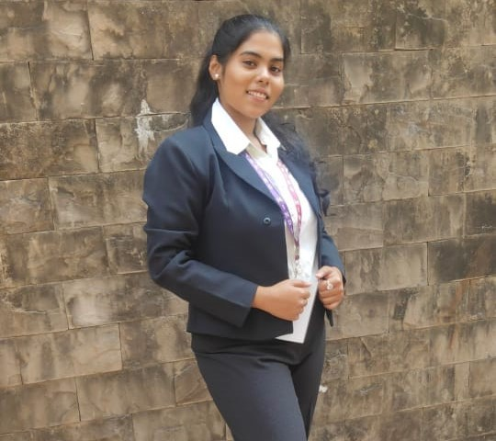

**LANGUAGE- ENGLISH, HINDI, MARATHI FOOD BLOGGER (MUMBAI FOODIE)**

**RUNING A SMALL STARTUP OF CLOTHING AND VARIOUS ACCESSORIES**