Jolene Dsouza

**2/14, Garden View Building,**

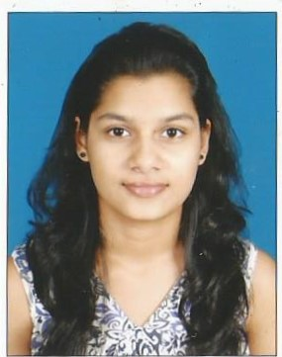

**E.S. Patanwala Marg,**

**Byculla East, Mumbai-400027.**

**Date of Birth**: 29th October 1998.

**Sex**: Female.

**Marital Status**: Single.

**Mob: 9619953014**

**Email ID**: jolene.dsouza.jd@gmail.com

**Languages Known**: English and Hindi.

Educational Qualifications

|  |  |  |  |
| --- | --- | --- | --- |
| **LEVEL** | **BOARD** | **YEAR of PASSING** | **CLASS  OBTAINED** |
| Graduation (3 years) | Mumbai University | 2019 | First Class |
| Higher Secondary Certificate | Maharashtra State Board | 2016 | Second Class |
| Secondary School Certificate | Maharashtra State Board | 2014 | First Class |

Other Qualifications

|  |  |  |  |
| --- | --- | --- | --- |
| INSTITUTION | COURSE NAME | YEAR OF PASSING | GRADE OBTAINED |
| Aptech Computer Education | Smart Professional-MIS | 2018 | Distinction |
| Welingkar Institute of Management | Human Resource Management | pursuing |  |
|  |  |  |  |

**Work Experience**

Job Profile : HR Executive

Company Name : GSPK Consultancy Pvt. Ltd

From 1st October 2019 - Present

Strength

* Good Communication Skills.
* Speak Fluent English.
* Basic Computer Skills.

Career Objective

Seeking a position with a dynamic organization where I can learn as well contribute to the growth of the organization with my skills.