CURRICULUM VITAE

Emai Id:- sandeshprajapati1@gmail.com Mob: 8419890726
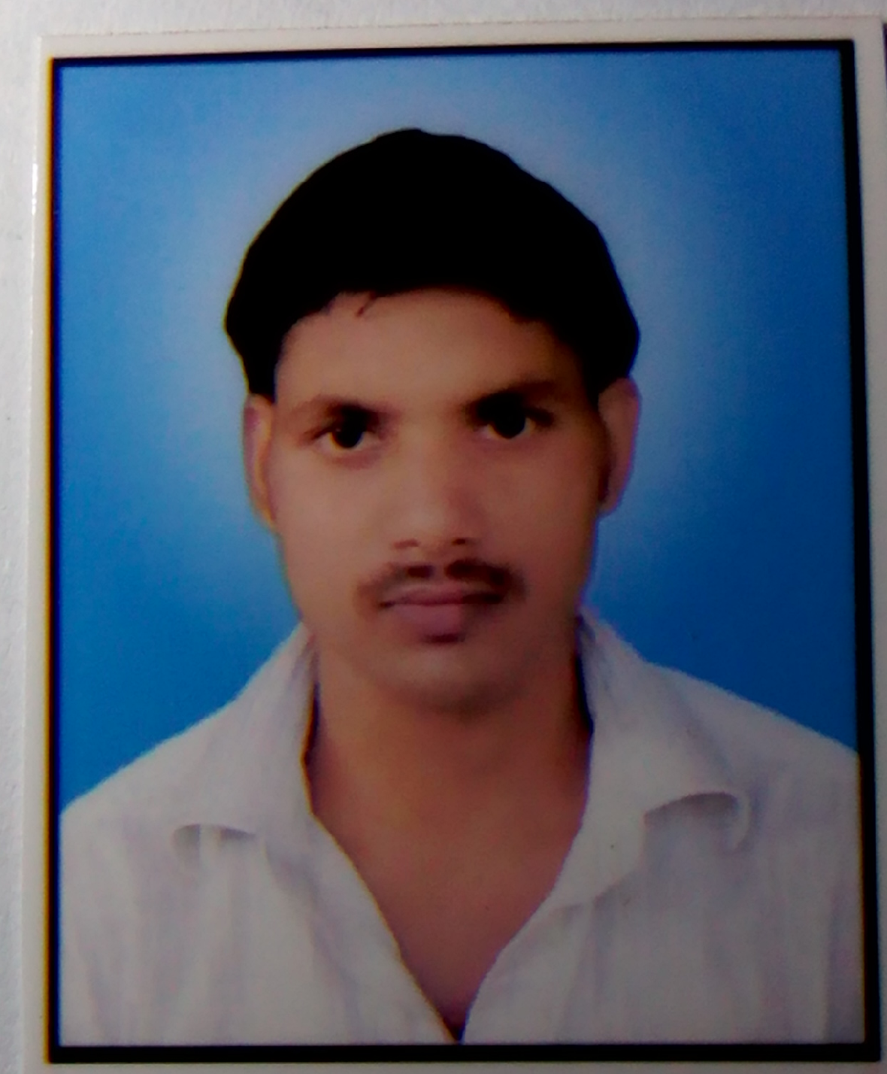
SANDESH KUMAR PRAJAPATI
Vill:- Bhawanpur
Post:- Ariyaso
Dist:- Mau

CAREER OBJECTIVE: To get the best exposure and expertise in the service industry by putting my continuous effort and dedication.

EDUCATIONAL QUALIFICATION:
- 10th from U.P. Board.
- 12th from U.P. Board.
Technical
- ICT with Computer (INFORMATION & COMMUNICATION TECHNOLOGY)
- DCA + TALLY 9.0
- Work :- M.S WORD, M.S POWERPOINT, M.S EXCEL, TALLY
CORE COMPETENCY:

- Desire to learn.
- Ability to work in team.
- Positive attitude towards work.
- Hard Working Honest

PERSONAL DETAILS:

Date of Birth : 01/06/1992
Father’s Name : Mr. Ramu Prajap ati
Mother’s Name : Mrs. Meena Devi
Marital Status : Unmarried
Language Known : Hindi
Permanent Address : Vill : Bhawanpur Post: Ariyaso
Mau, (U.P.) Pin: (275105)
Hobbies : Playing Cricket.

DECLARATION:
Further details if any desire shall be furnished on hearing from you I hereby declare that all the above information are facts to best of my knowledge and belief.

Date:
Place : Bhawanpur Sandesh Kumar Prajapati

