Resume

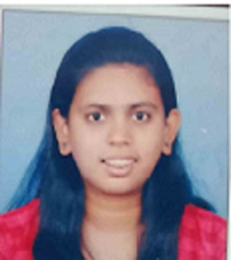

**ROHINI SAMBHAJI DUDHMAL**

Address: Saste Park, Saswad

Pin code: 412301

Email id: [sydudhmal@gmail.com](mailto:sydudhmal@gmail.com)

Mobile no.: 8380075279

**CAREER OBJECTIVE**

To initiate my career with an organization that will utilize my technical, discipline, regulation and directorial skill to benefit mutual growth and success of organization and society.

**ACADEMIC PROFILE**

|  |  |  |  |  |
| --- | --- | --- | --- | --- |
| **Degree/Certificate** | **University/Board** | **College/School** | **Percentage/SGPA** | **Year of Passing** |
| B.E(Computer) | Savitribai Phule Pune University | Keystone School Of Engineering. Pune | 71.54% | 2021 |
| XII | Maharashtra state Board | PDEA Waghire college, Saswad | 63.57% | 2017 |
| **X** | Maharashtra State Board | Waghire Highschool, saswad | 77.49% | 2015 |

**SKILL SET**

* OS : windows 10
* Programming languages : Basic knowledge of C, C++,PYTHON, HTML, JAVA
* Database : SQL

**EXTRA-CURRICULAR ACTIVITIES:**

Participation in college events, ACM

**OTHER ACHIEVEMENTS**

* Certified with “A” grade in Elementary (drawing).

**PERSONAL INFORMATION**

1. Strengths
   1. Adaptable to changes
   2. Hard working with optimistic nature
   3. Persistent in work
2. Languages known
   1. English – read, write, speak
   2. Hindi – read, write, speak
   3. French: basic

III. Hobbies

* 1. Sketching, crafting, drawing, dancing, cooking, baking, travelling

IV. Date of Birth – 28th May 1999

**DECLARATION**

I hereby declare that all the above- given information is true and factual to the best of my knowledge and belief.

Place: Pune

Date :

(Rohini Sambhaji Dudhmal )