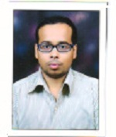**SACHIN SAHADEO TITARMARE**

**COMPUTER OPEARTOR & DATA ENTRY WORK**

**1.OBJECTIVE**

**I am graduate from ycmou. Who would like a**

**Secure position of data entry work and**

**Computer operator, within a development.**

**Sachintitarmare2017@gmail.com**

**I am also a computer teacher.**

**Contact No: 7038093408, 7385039524**

**2.EXPERIENCE**

**2015-present**

**Computer operator, data entry & computer**

**Teaching.**

**3. Education**

**2014-2018: graduation**

**Feb-2008: 12th pass**

**March-2006:10th pass**

**4. SKILLS**

**MS-office**

**MS-excel**

**MS- PowerPoint**

**Tally**

**Internet**