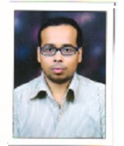
SACHIN SAHADEO TITARMARE
COMPUTER OPEARTOR & DATA ENTRY WORK
1. OBJECTIVE
I am graduate from ycmou. Who would like a
Secure position of data entry work and
Sachintitarmare2017@gmail.com
Computer operator, within a development.
I am also a computer teacher.
Contact No: 7038093408, 7385039524
2. EXPERIENCE
2015-present
Computer operator, data entry & computer
Teaching.
3. Education
2014-2018: graduation
Feb-2008: 12th pass
March-2006:10th pass
4. SKILLS
MS-office
MS-excel
MS- PowerPoint
Tally
Internet

