OBJECTIVE

I am an individual seeking an Executive position at a company that will allow me to learn the process, overcome the challenges in work and enhance my personal growth in the corporate world as well as enable me to contribute to the growth and development of the company.

EXPERIENCE

Digital Nirvana Information Systems Pvt Ltd | Jan 2020 – May 2020

Financial Reporter

I have served as a Financial Reporter for Transcription Process for a Multinational Company mentioned above based out in Coimbatore, TN. I used to do the Quality Check of the financial information of various companies’ earnings calls using appropriate and valid research and provide them in required format.

Cygnus E-Solutions Pvt Ltd | April 2019 –October 2019

Associate Transcriptionist/ Editor

I have served as an Associate Transcriptionist/Editor for Business Transcription Process. I used to provide raw financial information for various companies, according to their earnings calls.

Realteam Systems Pvt Ltd | May 2011 – September 2014

Associate Editor Level 1

I have served as an Associate Editor Level 1 for Business Transcription Process. I used to provide raw financial information to the senior associates by creating a format as per required by the company.

HOBBIES SKILLS

Dancing, Singing. MS Office, Provisional Certification in

Reading Books. Computer Languages- (V.B., Oracle,

Cooking, Listening Music. HTML, DHTML, C, C++)

Yoga. Certification in Typing (English,

Marathi30w.p.m. 40 w.p.m.)

& 40 w.p.m.)

MADHAVI MURLIDHAR MORE

Financial Reporter
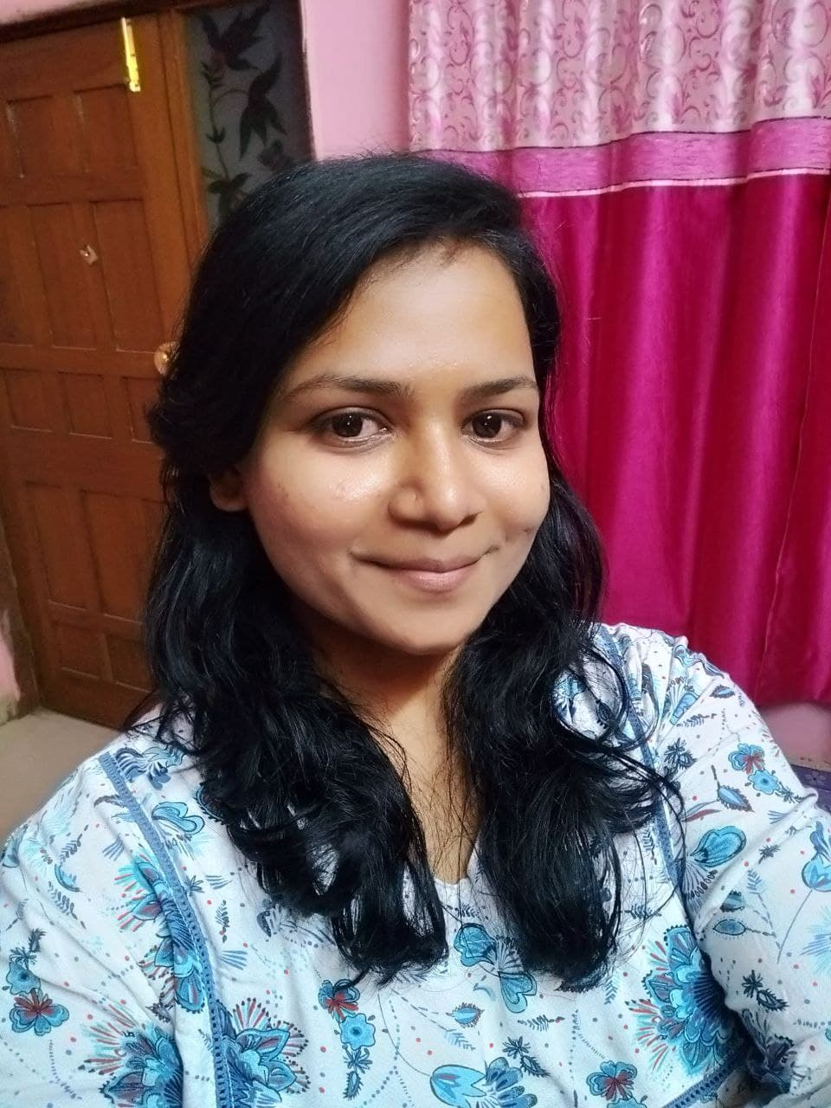
CONTACT
Mob. No. 9970047774
Email ID:
mrome.550@gmail.com

EDUCATION
Masters of Arts
(English Literature)
June 2015 – June 2017
Sardar Dalipsingh Arts & Swami Vivekanand Science & Commerce College, A’bad.
Bachelor of Arts
(English Literature)
June 2006 – October 2010
SB College, A’bad. YCMOU
H.S.C.
(Science Stream)
June 2002 – June 2004
Govt. College of Arts & Science, Aurangabad.
S.S.C.
(English Medium) June 2002. St. Xavier’s English High School, A’bad.

