RESUME
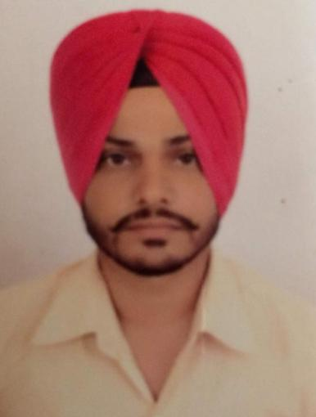
BIKRAM SINGH
Permanent Address:
Vill. Dadiana-kalan
PO Hariana
Tehsil & Distt. Hoshiarpur (PB)
Contact No. 09592170473
Email id: bikramsingh22273@gmail.com

CARRIER OBJECTIVE:-
- Looking for a carrier growth to be associated, where my ability, honesty, constant hard work can be used for future growth.
ACADEMIC QUALIFICATION:-
- 10th passed from Punjab Board Mohali
TECHNICAL QUALIFICATION:-
- Three years Diploma in Plastic technology from PSBTE Chandigarh in session 2008 to 2011.
TRAINING:
- Two months industrial training with M/s. Elin Electronics ltd baddi HP
EXPERIENCE:-
- Presently working with M/s Godrej and boyces mfg.company ltd.(Mohali), in injection moulding department as Assistant Executive, From 3 november 2014 to till date
- Worked with M/s Precision Moulds & Dies Pvt. Ltd. Baghbania, Teh- Nalagarh, Solan H.P. As Supervisor from 16 December 2013 to 3 November 2014 injection moulding.
- Worked with M/s. Elin Electronics ltd at baddi HP as Technical associate from Aug 2011 to 16 December 2013 injection moulding.

RESPONIBILITIES:-
- Handling independent shift and To achieve the production target according to the production plan
- Hand on experience of machines from 50T to 3500T IM machine.
- Trouble shooting and maintenance of Windsor,Bole and Hwachin Injection moulding machine.
- Daily reporting the production to HOD
- Breakdown intimation to maintained department
- New molds trials and stabilization of processing on machine
- Approval of first piece and last piece inspection
- Solve troubleshooting during production
- Maintaining 5’s at shop floor
- TPM circle leader and undergone TPM training and activities.
- Ensuring safety through training and kaizen’s
- Manpower handling and deployment according to their skills
- Responsible for safety of man,machines in the shop
MACHINE HANDLING:-
- Haitian, Jetmaster Super master sumitomo Cincinnati Milacron,Hwachin 3500 ton, Mafatlal niigata. L&T, Windsor and Bole.
STRENGTH:-
- Good communication Skill
- Positive Attitude
- Hardworking & Honest
PERSONAL INFORMATION:-
- Date of Birth 15/11/1989
- Father’s Name Sh. Baldev singh
- Nationality Indian
- Language known Hindi & English
- Gender Male
- Marital status Single
DECLARETION:-
- I hereby declare that the given above information are true as per my knowledge & belief.
Place:…………………
Date:…../……./……… BIKRAM SINGH

