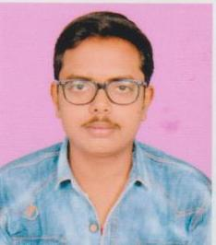
CURRICULUM VITAE

NISHANT TIWARI
ADDRESS- C44 Dayal recienency Near B.B.D

Email: nishanttiwari656@gmail.com
Mobile NO: 8808852500
CAREER OBJECTIVES
Seeking a challenging and rewarding opportunity with an organization of repute which recognizes and utilizes my true potential while nurturing analytical and technical skills
SUMMARY
- A hardworking, resourceful and ambitious economics and commerce student with extensive understanding of economics & accounting theory.
- Good people skills ability to communicate effectively and build long lasting/ mutually beneficial relationships.
- Highly motivated, positive and goal-oriented, with a high degree of flexibility, resourcefulness and commitment to work
- Excellent temperament to work in a team, multi-task as well as coordinate between various activities efficiently
Core Competencies
- Good interpersonal skills
- Vast knowledge of Accounting And Economics
- Excellent communication skills
- Good analytical and problem solving skills
EDUCATIONAL CREDENTIALS
- Pursing B.COM from Techno group of institution
- XIIth from Radiant College, CBSE Board in 2018
- X^{h} from Divine Public school, CBSEBoard in 2016
- ComputerProficiency:MSOffice,Internet,Tally,Typing&CCCEXTRA CURRICULAR ACCOLADES
- Participated in presentation competition,
- First prize in debate&Sports competition,
- Cultural activities participation and work as head captain of cultural activity
- Participated in adventures tracking of school.
- First Prize In Photography Competition
PERSONAL DETAILS
- Date of Birth: 21JUNE 2000
- Languages Known: English, Hindi

