 | Ms. RUPALI DILIP KADAM |  |  |  | 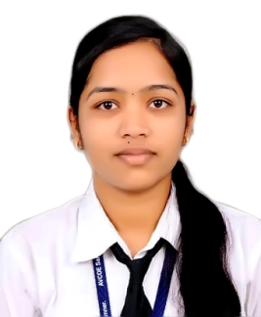
 |  | A/P-Belpimpalgaon Tal- Newasa Dist –Ahmednagar 413725.…………………………………
 |  | 05/02/1999 |  | kadam333rupali@gmail.com
 |  | 8459421776  / 8805658269 |  | http://www.linkedin.com/in/rupalikadam-19980416a

 | Career Objective:
 | To be a part of an organization where I can fully utilize and enhance my knowledge,skills and techniques and make a contribution to the success of the employer and at the same time ,my individual growth.
 | Educational Qualification:( BE- Computer, Diploma-Computer)
Qualification | Year | College | University | % / CGPA | Class
BE | 2019-20 | Amrutvahini College of Engineering, Sangamner, Dist.: Ahemednagar | SPPU, PUNE | Pursuing | Pursuing
TE | 2018-19 |  | SPPU, PUNE | 7.54 | First Class
SE | 2017-18 |  | SPPU, PUNE | 7.98 | Distinction
Diploma | 2014-17 | Government Polytechnic, Ambad | MSBTE | 78.00 | Distinction
SSC | 2013-14 | Shri hanuman Vidyalaya Belpimpalgaon | PUNE Board | 88.80 | Distinction

 | Achievements:
- Workshop Attended:
- AngularJS
 | Certification Courses:
 | - MSCIT
 | Languages:
 | Marathi, Hindi, English
 | Software Skills:
 | Basic of C, C++, JAVA, Advanced JAVA,HTML
 | Basic of MySQL, Oracle
 | Project:
1. | Smart irrigation system(TE )
 | Objective: To check the soil moisture level And produce output by Blinking LED.
 | Guided by: Prof. S. B. Bhonde.
2. | Clearance form(TE)
 | Objective- To generate the clearance form which help the teacher.
 | Guided By- Prof. R.S.Jangale.
 | Strength:
 | Team Builder, Honest, Hard Working,quick learner
 | Hobbies:
 | Cooking, Listening songs,Drawing

Date:
Place: Sangamner (Ms. Rupali Dilip Kadam)

