**Mr CH.GEETHARAM**

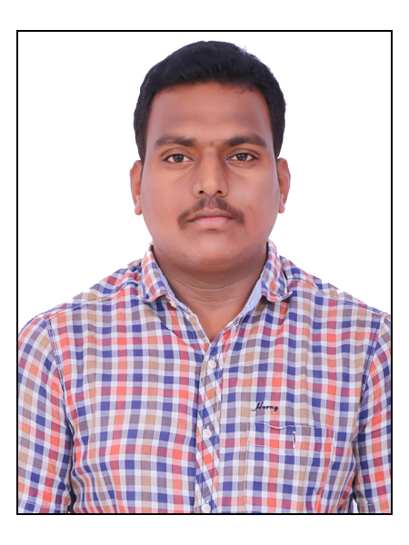

Sr Chemist-QC

Celon Laboratories Pvt Ltd.

E-mail: [geetharamchalapati9@gmail.com](mailto:geetharamchalapati9@gmail.com)

Geetharam.ch@celonlabs.com

Mob- 9491979255,9160072920

.

**EDUCATION**

Kanaparthi Bhava Narayana PG College Vijayawada Krishna dist

M.Sc (organic chemistry) **2013 - 2015**

Andhara Loyola Degree college Vijayawada Krishna dist

B.Sc (chemistry) **2010 - 2013**

**CAREER OBJECTIVE**

To obtain a challenging position in a high quality organization where my resourceful experience and academic skills will add value to organizational operations.

**WORK EXPERIENCE**  (02 years)

**Current position**

* Working as Senior Chemist in Quality Control department since oct 11 at

Celon laboratories PVT LTD.

**Previous experience**

* Worked as chemist in Quality control department at Sri Krishna Pharma UPPAL Hyderabad from April 2018 to Oct 2019
* Worked as Chemist in Quality Control department at Hetero Drugs Pvt LTD. Bonthapally , Gagilapur Rangareddy Dist from Jan 2017 to Mar 2018.

**AREAS OF INTEREST**

* Quality control
* Quality Assurance

**JOB DESCRIPTION**

* Sampling of API & Packing materials.
* Analysis of API, Intermediates, Packing materials except – HPLC & GC
* Analysis of validations customer compliants,return goods,repacking
* Reagents and Volumetric solution preparation & standardization.
* Calibrations of all instruments in wet chemistry laboratory.
* Preparation of composite samples & reserve samples.
* Reporting of any OOS/OOT/INCIDENCE observed in the laboratory.
* Labeling activity such as affixing under test, approved and rejected labels to API,

intermediate, packing materials.

* Upkeep Of Records As Per Good Documentation Practices.
* To Follow Good Laboratory Practices.
* Any Other Task Given By Head Qc/Designee.

**INSTRUMENT KNOWLEDGE**

Have sound knowledge and handling experience of various analytical instruments, which are:-

* UV, IR, Potentiometer, colorimeter,
* KF Titrator, PH meter. Bulk Density, Sieve shaker,
* HPLC Shimadzu I Prominence 2030 Plus

**SOFTWARE KNOWLEDGE**

Experienced with software such as;

* Spectra Manager 2.14, UV probe 2.52, Tiamo 2.5
* Lab Solutions
* Quality Management Software, Learning Management Software.
* MS office,SAS

**EXTRA CURRICULAR ACTIVITIES**

* Participated in several group discussions seminars & debates
* Active member in organizing Fresher’s and farewell parties at college

**Projects:**

* ANALYSIS OF IONS IN VARIOUS SAMPLES OF TOOTHPASTE
* PHYSICO-CHEMICAL ANALYSIS OF GROUND WATER SAMPLES OF SELECTED AREAS IN MYLAVARAM, KRISHNA (Dist.) ANDHRA PRADESH

**DECLARATION**

I hereby declare that the above mentioned details are true to the best of my knowledge.

Ch Geetharam

Hyderabad

Telangana, 500068