Bhavya Sharma Undergraduate Student
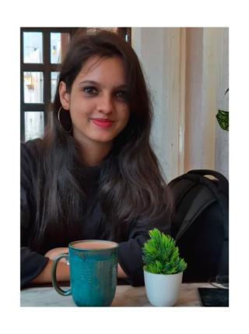

57/1 K.N. Sen road , kasba, 700042 Kolkata, India

sharmabhavya2211@gmail.com | 8240823451 | 22 Jan 2001

https://www.linkedin.com/in/bhavya-sharma2211/

https://www.instagram.com/the_vacillating_soul/ https://www.facebook.com/bhavyasharma2211/

 PROFILE

I am an enthusiastic fresher, currently pursuing a bachelors degree in commerce and finance. I am a highly motivated individual and always eager to learn new things with strong motivational and leadership skills. I am excellent when it comes to communication. And I also possess the ability to work as an individual as well as in a group.

EDUCATION

2019 – 2022 B.com Hons, Calcutta University

Kolkata, India An Honours Program in Finance and Accounting that I am currently pursuing.

It enabled me to have a multifaceted approach to dealing with the problems at

hand. I participated in various campus programs and it was beneficial for my

personality development.

Highlights:

9.20/10 GPA.

Member of the Student Debate Club for two years

Creator of the social media page of the club.

Played a crucial role in promoting the values and interests of the Literary Society

2004 – 2019 Higher Secondary, Dolna Day School

Kolkata, India A small institution with an integrated set of values promotes the cultural aspects

of the city.

Highlights:

8.9 CGPA

PROFESSIONAL EXPERIENCE


Jan 2022 – present Student Intern, Leaflets

Kolkata, India Actively doing research on the environment and sustainability.

Publishing articles based on sustainability and environmental crisis around

the globe.

Learning about journalism and technology such as Firebase.

Oct 2020 – Mar 2021 Campus Ambassador, Viral Fission

Kolkata, India Bringing in engagement for the companies like Vice & Myntra on social media

platforms.

Helping in maintaining active communication among the other ambassadors

and teammates.

sharmabhavya2211@gmail.com 1 / 2

Sep 2020 – Mar 2021 Team Leader, Groovex

Kolkata, India Planning, developing and implementing various action plans.

Helping the team to achieve the targets and excel in the tasks

Active participation in the recruitment process.

Managing the offline campaigns.

Managed a team of 20 and maintained a healthy & cheerful working

atmosphere.

SKILLS


Communication

Able to communicate with empathy with patience of listening and addressing various view points

Content Writing

Have the ability to produce quality work in the sphere of writing
possess experience in ghostwriting.


AWARDS

People Skills

Proving to be of great help while working in a team or leading a team
able to co-ordinate and acclimate to the diverse ambience
always up for learning something new

Social Media Management

Ability to manage social media platforms and produce creative ideas in the area of digital marketing.

2018 Institutional Level Winner in All India Essay Writing,

Shri Ram Chandra Mission

Procured the institutional level award for producing an exceptional essay and portrayed keen knowledge of mother tongue ( Hindi)

2017 Awarded for Goodness And Effort, Dolna Day School

Awarded for exceptional behaviour with peers and teachers, portraying kind behaviour towards the needy, and being helpful round the clock

 CERTIFICATES

Social Media Marketing - What is Social (Level 1) Transmedia Storytelling


LANGUAGES

Hindi English Bengali

 INTERESTS

Writing Yoga Culinary Arts Feedreading

sharmabhavya2211@gmail.com 2 / 2

