CURRICULAM VITAE
BHUPENDER KUMAR  RZF – 362, Guru Nanak Marg,  Raj Nagar – II, Palam Colony,  New Delhi-110077.  E-Mail: bhupenderkmr2009@gmail.com  Contact No: +91-9990609099, 9717770363 | 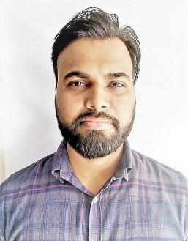
CAREER OBJECTIVE

To be a part of a reputed organization where skills and creative are observed and work for long-term in same organization to increase my skills and to become professional in same field with developed professional skills.

PROFESSIONAL EXPERIENCE

Office Assistant

Bharat Heavy Electricals Limited (On Contract) (July, 14 to Till Date)

- Attending Calls and conferencing.

- Preparing Vendors Bills.

- Processing of Telephone Bills in SAP.

- Process & Keeping record of Furniture Furnishing Bills.

- Booking of Guest House & Hotels for Officials Tours.

- Paying all kinds of personal Bills.

- Keeping records of all kinds of incoming & outgoing Daks.

Lower Division Clerk
N.M.C.C. (Ministry of Commerce & Industry) (Jan, 11 to June, 14)

- Airport Protocol Duties.

- Noting & Drafting of Letters.
- Keeping record of all incoming & Outgoing Dak.
- Preparing Salary, LTC, OTA etc. Bills.

- Arrangement of Officials Meeting.

Tele Caller Executive
AEGIS BPO Private Ltd. (Feb, 10 to Aug, 10)

- Handling Customers for their bills regarding Quarries.

PROFESSIONAL QUALIFICATION

- Diploma in Air Ticketing 6 Month Regular Course from YMCA.

- Basic Computer Knowledge with typing speed of 35WPM.

EDUCATIONAL QUALIFICATION

- B.A. from Delhi University in 2010.

- 12th passed from C.B.S.E Board Delhi in 2006.

- 10th passed from C.B.S.E Board Delhi in 2004.

PERSONAL DETAILS

Father’s Name | Sh. Sita Ram
Mother’s Name | Smt. Laxmi Devi
Date of Birth | 29th July, 1985
Language | English, Hindi (Read/Write/Speak)
Marital Status | Married
Nationality | Indian
Religion | Hindu
Hobbies | Listening Music & Playing Cricket
Mother Tongue | Hindi
Category | SC

Declaration: I hereby declare that all the above given information is true to my knowledge & original will be produced as and when required.

Place: New Delhi
Date: (BHUPENDER KUMAR)

