

KK UNNIKRISHNAN
AGM-FINANCE & ACCOUNTS
Day to day Accounts Deptt functions
Oracle Financials / AR/GL/AP
Location Preference: GCC/Open

unnikrishhnankk@gmail.com/kkunnikrishnan@dharti.in+91-9100660284
Profile Summary
- Expertise in the management of complex projects and a multi-cultural team at International location like Turkey,Qatar,UAE etc, with nearly 30 years of experience in Vendor Management, Bank Accounts Management/Bank Reconciliation, Cash Management & all day to day accounts functions.
- Have an impressive cosmopolitan background &interests in other cultures, with a command of various Indian languages
- Rapid adaptability to new problem-solving techniques / working in new locations with outstanding `s in interacting with clients, understanding their requirements and accordingly devising customized & cost-effective solutions, maintaining complete client satisfaction and creating repeat business opportunities
- Skills in commencing Accounts Work Analysis; analysing quarterly fluctuations in Balance Sheet Accounts; conducting root cause analysis of accounts having major fluctuations on a quarterly basis
- Resourceful in managing Oracle Financials, accounting packages and streamlining the process flow of accounts payable and contributing positively in ERP Implementation
- A keen communicator with honed interpersonal, analytical and problem solving skills
- Computer Skills : Good exposure in Oracle Financials (GL/AP/Inventory). Tally 9 & above

Areas of Exposure

Accounting | Accounts Payable | Accounts Receivable
Compliance/Internal-external audit support | Reporting & Documentation | Payment Transactions
Vendor Management | Project Management(Support)  Banking/LC/TR Management | Cash Management/Payroll Management

Growth Path

Jun’13-Onwards
In-charge - Finance and Accounts, as Sr.Manager/AGM

MM’84- Apr’93
Accounts Assistant/ Accountant/Sr. Accountant/Executive-F&A

Jun’07-Jun’13
In-charge - Finance and Accounts,

Since Jun’13
Senior Manager-Finance & Accounts
May’03-Jun’07
Deputy Manager – Finance and Accounts
Apr’93-May’03
Sr. Executive / In-charge – Accounts and Finance


Work Experience

Present : Dharti Dredging And Infrastructure Limited
Designation : AGM-Finance & Accounts
Project : LNG Terminal Project, Gujrat. Owner – Swan Energy Limited
Job profile : Day to day activities of Finance & Accounts, HR, Psl & Admin, Procurement

Upto March 2016.
Punj Lloyd Limited, Abu Dhabi, UAE as Senior Manager-Finance & Accounts

Growth Path/Deputation:
Jun’84-Apr’93 Accounts Assistant/ Accountant/Sr. Accountant/Executive-F&A
Apr’93-May’03 Sr. Executive / In-charge – Accounts and Finance for various Projects
May’03-Jun’07 Deputy Manager – Finance and Accounts, Punj Lloyd – Limak JV, Turkey
Jun’07-Jun’13 In-charge - Finance and Accounts, Qatar
Since Jun’13 Senior Manager (Finance and Accounts, Regional Office MEA CIS Region, Abu Dhabi

Key Result Areas:
- Dealing with Local & International Banks Concerning, Liquidity, and LC & BG Management
- Managing day-to-day functions of Accounts & coordinating with Finance Team /strategies for Project start-up including BGs &Credit facilities with banks for Company’s Projects
- Supporting Finance Team for reviewing Balance Sheet Accounts &Profit & Loss Accounts at unit level; ensuring integrity of all reported financial statements
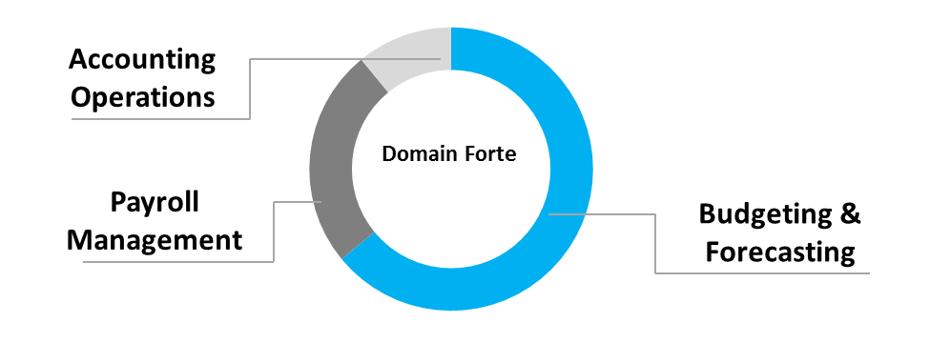
- Supporting the statutory audit, treasury, finance and administering letter of credits, bank guarantees
- Devising, calculating and interpreting key accounting ratios for enabling effective performance management
- Developing payable controls & procedures that improve timeliness and accuracy of both the recording and payment of transactions
- Supervising the month-end closing process and reconciliation of ledgers
- Maintaining adherence to corporate, accounting and GAAP standards; addressing escalated Accounts Payable issues raised by employees and vendors; ensuring accurate and compliant files and records in line with company policies and government regulations
- Connecting with over 1000 suppliers/Sub-Contractors & re-conciliating their accounts
- Planning and executing monthly/quarterly/annual closure schedules; providing monthly financial statements; administering the monthly closing process
- Keeping a record of reclassification & accounting of wrong or unaccounted entries prior to closure of General Ledger
- Designing rolling forecasts for cash flow, profit & loss projections for review by management; undertaking risk and return analysis, sensitivity analysis for the short and long term
- Monitoring timely payments to vendors as per the agreed credit period; spearheading the reconciliation of Vendor Account on a periodic basis

Highlights:
- Successfully implemented /strategies for project start up including BGs &Credit Facilities with banks for Company’s Projects in Qatar
- Bagged Long Service Award for giving long term contribution in the excellence of organization in 1997, 2007, 2012
- Valued by top management for performing fabulously in the execution of the several projects during the year 2003 to 2013 in Turkey/Qatar & Abu Dhabi
- Attended in-house training organized by the company
- Managed Turnkey projects with international Joint Venture Partner, M/s Limak, Turkey for prestigious Cross-Country Pipe Line Project, Baku-Tiblizi- Ceyhan Pipe Line Project Owned by British Petroleum in the year 2003-2005
- Administered Company’s Prestigious International Gas Pipeline Project in Bangladesh
- Automated the preparation of more than 15 daily/weekly/monthlyreports using computer skillsthat had previously required severalhours of effort per week
Education
- 10thfrom St. Peters Higher Secondary School, Kolenchery, Ernakulam Dist, Kerala Higher Secondary Examination Board in 1978
Personal Details
Date of Birth: 22ndOctober 1962
Languages Known: English, Hindi and Malayalam
Address: Kalleril House, Pattimattom-683562, Kerala, India
(Refer to Annexure for Organizational Projects)

ANNEXURE

Organizational Projects
Project Title BTC Pipeline Project
Client British Petroleum/Turkey
Duration 2.5 years
Team Size 12 (Finance/accounts team)
Project Cost $ 400mn Approx.
Environment Oracle Financials
Project Description Construction of 1750Km Cross Country Crude Oil Pipeline Project from Baku-Tibilisi-Ceyhan
Designation Dy. Manager-Finance & Accounts
Responsibilities:
- Monitored the entire functions of accounts including payroll & MIS, support for finalization/consolidation of accounts for quarterly audits
- Dealt with local & International banks
Project Title Strategic Gas Pipeline Project/ Polycilicon Process Plant
Client Qatar Petroleum/Qatar Solar Technologies - Doha/Qatar
Duration 6 Years
Team Size 7 (Finance/account team)
Project Cost $ 2.4 BN Plus
Environment Oracle Financials
Project Description Engineering, Procurement, Installation, and Commissioning of Strategic Gas Transmission, Project. The project includes laying of 211 km of pipeline with associated stations and infrastructure. EPC project for manufacturing high quality Polycilicon-Process Plant. There were other 3 projects from Qatar Petroleum (Construction of Gas Pipelines), one contract from Bactel for EPC package to construct jet fuel receiving stations, fuel distribution system.
Designation Manager - Finance & Accounts
Responsibilities:
- Administered the entire functions of accounts including payroll & MIS, support for finalization/consolidation of accounts for quarterly audits.
- Liaised with local & International banks

Project Title 5 various projects
Client ADCO/ENOC-UAE
Duration Ongoing Project since 2013
Team Size 8 (Finance/accounts team)
Project Cost $ 625MN PLUS
Environment Oracle Financials
Project Description Construction of Gas pipelines of Abu Dhabi Co. for Onshore Petroleum Operations, Emirates National Oil Company, Field Development project from ADCO, Spiking Gas Compression Project from ADCO.
Designation Senior Manager-Finance & Accounts

Responsibilities:
- Supervised for the Accounts Payable and dealt with Local & International Banks
- Managed 1000 string suppliers/sub-contractors, invoice control & MIS
- Provided support for finalization/consolidation of accounts for quarterly audits
Designation From Account to Sr. Executive-Finance & Accounts
Responsibilities: Functions of Finance/Accounts Dept.
- For various Projects in India (Cross Country Pipeline, Process Plants, Road Projects (more than 20 small & high budget projects of Punj Lloyd Ltd.) since 1984.

