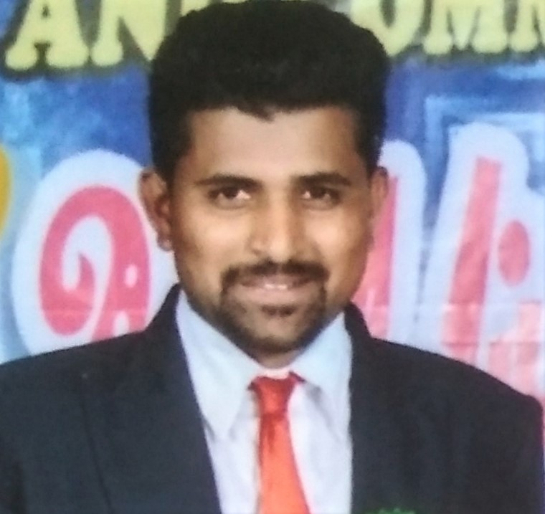

**Personal Details**

Date of Birth: 20-05-1992 Gender: Male

Marital Status: Married Nationality: Indian

**Permanent Address:**  R S Upparahatti village

Byadarahally post Hiriyur Taluk

Chitradurga 577546 Karnataka, India

**Languages Known:**

1. English,
2. Hindi,
3. Kannada,
4. Telugu

**Hobbies**

Playing Cricket , Photography , swimming.

|  |  |  |  |  |
| --- | --- | --- | --- | --- |
| **VENKATARAMU V**  **Email :** [**venkataramu54@gmail.com**](mailto:venkataramu54@gmail.com)  **Mob No :** 9663031928 / 6363723793 – WhatsApp  **Career Objective**   * To achieve a sound position in the corporate world and work enthusiastically with a team to achieve the goals of the organization. * To work in a dynamic organization with the challenging work environment and a growth it’s as responsible and a key member of the organization. To make best use of the abilities, qualification and experience with the quest to learn more.   **Professional Qualification** | | | | |
|  | Course | College | Board/University | Percentage |
|  | S.S.L.C | Parthlingeshwara High School | Karnataka Secondary Education  Examination Board | 73.12% |
|  | Diploma | Gnana vikasa polytecnic | Department of Technical Examination | 65.55% |
|  | Graduation (B.E E&C) | GEC Ballary | VTU Belagavi | 55.22% |
| **Technical Skills**   * ***CCNA Course Completed*** * *Others*:   o Microsoft Office(Word, Excel, PowerPoint)  **Work Experience**  **WORKED IN BHANDARY CORPORATION AS “COMPUTER HARDWARE ENGINEER"**  JUNE 2017 TO JULY 2020   * Install, upgrade, support and troubleshoot Windows OS, authorized desktop applications and Hardware. * Overseeing system performance troubleshooting issues of computer, printers etc.   **WORKING IN HINDUSTAN AERONAUTICS LIMITED (HAL) AS “DESKTOP SUPPORT ENGINEER”**  AUGUST 2020 TO PRESENT   * Install, upgrade, support and troubleshoot Windows OS, authorized desktop applications and Hardware. * Overseeing system performance troubleshooting issues of computer, printers etc. * Setting up new users and giving them access to the intranet | | | | |

## Strengths

* Computer skills
* Positive attitude and dedication towards the work.
* Can work in a team activity
* Ability to deal with people diplomatically.

## Declaration

The above particulars are true and best of my knowledge. I believe that you will consider my application favorably and grant me an interview and opportunity to give you more information about myself.

# DATE :

PLACE : Bangaluru

VENKATARAMU V