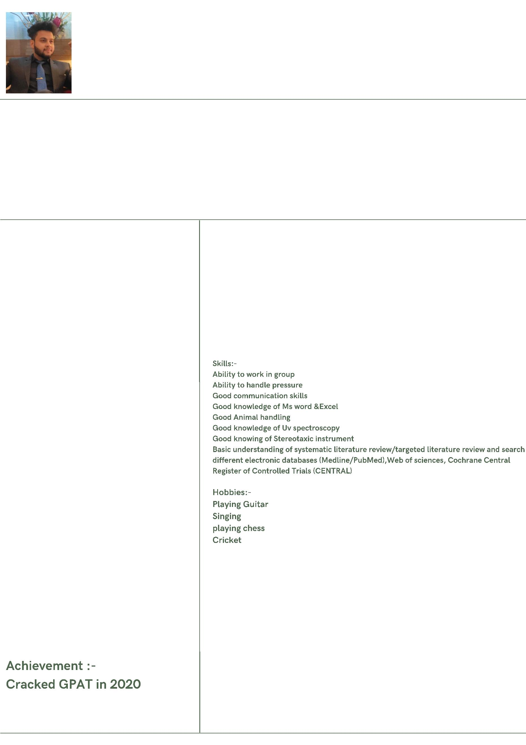
MOHD. NAZISH QUASMI
As a Pharmacist and student of Pharmacology I'm seeking a challenging position with an
organization in the field, where I can enhance and develop my education, training and creative skills
to become an effective team member who contributes to the success of the organization
RELEVANT EXPERIENCE
Mail ID :- nquasmi2755@gmail.com,
Phone No. +917018203784,
+919459687569
1 Month Training in Corona Pvt Ltd Solan (H.P) in Bachelor's
Projects :
Address:- House No. 66 Raura Sector 2
Bilaspur, Himachal Pradesh (India)
LinkedIn :-
https://www.linkedin.com/in/nazish-
quasmi-248869198
B.Pharmacy :- Ringworm / Dermatophytosis
M.Pharmacy(Pursuing) :- Evaluation of neuroprotective effect of
Bacopa monnieri and Mucuna pruriens in 6 OHDA model of Parkinson
Disease in rats.
EDUCATION
M.pharmacy(Pharmacology) 2020-2022
From Jamia Hamdard
New Delhi.(Current Percentage :- 78%)
B.pharmacy (2016-2020)
From Shoolini University
Solan (H.P).(OGPA :- 6.2)
10+2 (2016)
From Minerva sr. sec. school
Ghumarwin (H.P).(Percentage :- 72%)
EXTRACURRICULAR ACTIVITIES
10 (2014)
From Bilaspur Public School
Bilaspur(H.P).(Percentage :- 75%)
1.Participated in National Pharmacy Conference held at Rayat Bahara
(Kharar).
2.Participated in State Level Chess Competition & Winner of Dist. Level
Chess Competition.
3.President of Music Club of University.
4.Head of “MOKSH” University’s Tech. Fest Leading “Singing
Competition & Battles Of Band”.
5.Student Coordinator of Interdepartmental competition held at
University.
6.Core Member of Induction Buddy Program held at University.
7.Participant of ‘World Pharmacist Day’ organized on theme
“Pharmacist”.

