CURRICULUM VITAE
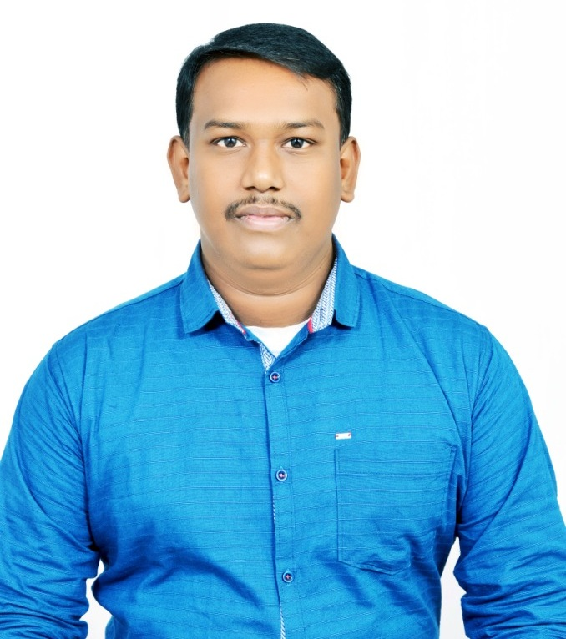
ANUPOM DAS
Contact No’s: Mob — (+91) 9883314605 / 7003176857 E-mail :- anupom1987@gmail.com
------------------------------------------------------------------------------------------------------------------------------

OBJECTIVE : To work in a globally competitive and dynamic environment which gives me a change to utilize my skills and abilities in the Mechanical Industry and enable me enhance my technical skills.

TECHNICAL
KNOWLEDGE : Passed I.T.I. with 82.2% in 2006 from I.T.I. College, Hooghly, West Bengal .

OTHER
QUALIFICATION : Basic Knowledge of Computer (DOS, Windows, MS-Office) ,
Solidworks, Passed AutoCAD from Yuva Computer Centre with 83.5% in 2007.

ACADEMIC QUALIFICATION :

Name Of The  Examination | Year Of Passing | Percentage (%) | Total | Board/Council/University
Graduation ( Bsc.-Geography ) | 2009 | 55.5 | 388 | N.S.O.U.
I.T.I.( Draftsman-Mech ) | 2006 | 82.2 | 518 | N.C.V.T.
Higher Secondary | 2004 | 54.5 | 545 | W.B.C.H.S.E.
Madhyamik | 2002 | 62.9 | 503 | W.B.B.S.E.

SKILS : Preparing , modifying & detailing various type of Mechanical Parts, Fabrication Items & Structural Drawing (2D & 3D) with Bill of Material . ( Like Conveyor , Ropeway , Pressure Vessel , Pulveriser, Vibrating Screen , Chimney , Heat Exchanger , Blower , Pump , Truss , Pipe line , Rice Mill Plant , Gas Cylinder Valves, Elevators , Lift items & other Mechanical parts etc.)
TRAINING : 1) One year Apprentice training (02.07.07 To 01.07.08) from M/S Kesoram Rayon , B. K. Birla group of Company, Tribeni , Hooghly, West Bengal.

2) ISO 9001:2015 and 14001:2015 Upgradation Training Course Completed in September, 2016.

EXPERIRNCE : 1) Worked (23.05.09 To 28.02.11) as a Draftsman (Mechanical) at M/S Annapurna Engineering & Manufacturing Pvt. Ltd. , ISO 9001:2008 Company, Bandel, Hooghly, W.B.

2) Worked (03.03.11 To 30.03.12) as a Draftsman (Mechanical) at M/S Conveyor & Ropeway Services Pvt. Ltd. , ISO 9001:2008 Company, 75-C, Park Street, Kolkata-700 016, W.B.

3) Worked (01.04.12 To 30.04.15) as a Draftsman (Mechanical) at M/S Dulichand Oils Pvt. Ltd. , 70 Diamond Harbour Road, Dhanshree Towers, Flat 3A & 3D, Kolkata – 700023, W.B.
4) Worked (04.05.15 To 31.12.18) as a Draftsman (Mechanical) at M/S Bharat Elevators & Engineers Pvt. Ltd. , ISO 9001:2008 & 14001:2004 Company, 22 Strand Road, 1st Floor, Kolkata - 700001, W.B.

5) Still Working as a Design Assistant at Tekno Valves , Natun Rasta, Bilkanda, North 24 Parganas., Kolkata – 700113, W.B.

CURRENT CTC : 3.5 Lakh per Annum.

EXPECTED CTC : 4.0 Lakh per Annum.

NOTICE PERIOD : 30 Days .

PERSONAL DETAILS

FATHER’S NAME : Late Nikash Ch Das.

ADDERSS : Nandan Kanan , Hooghly Station Road ,
P.O.- Bandel , Dist - Hooghly , Pin Code -712123 ,
West Bengal , INDIA.

DATE OF BRITH : 24th April 1987.

SEX : Male.

NATIONALITY : Indian.

RELIGION : Hindu.

COMMUNITY : General.

MARITAL STATUS : Married.

LANGUAGE PROFICIENCY : English, Hindi, Bengali.

HOBBIES : Collecting Coins.

I do here by declare that the above stated information’s are true to best of my knowledge and belief.

PLACE : Hooghly

DATE : --------------------------------------------------
( Signature of the Applicant )

