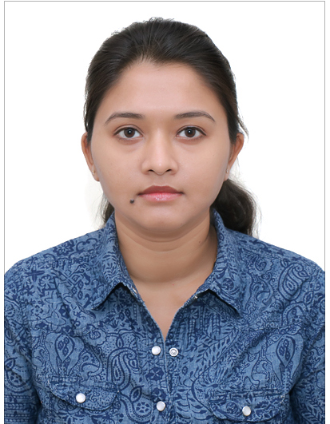
RESUME Tanusree Karmakar

Personal Data:

Permanent address : 4A/9, Naktala Road, Kolkata - 700047
Phone Nos.: 9830938094 & 8910759821.
Email id : karmakartanusree08@gmail.com
Nationality : Indian
Religion : Hindu.

Educational Qualification:

●Academic:
Passed Madhyamik Examination in 1997 under WBBSE with 73% marks.
Passed Higher Secondary Examination (10+2) in 1999 from WBCHSE with 60% marks.

● Technical:
Passed Diploma in Electrical Engineering in 2003 under WBSCTE(West Bengal State Council for Technical Education)from Hooghly Institute of Technology with 78 % marks..
Passed AMIE Sec-A in 2010.

Professional Experience:

1) Worked as electrical draftsman in CMS CONSULTANT Kolkata,from 2016 to till.
●Job Profile:
» Equipment layout,Single line diagram,lighting layout.

2) Worked as electrical draftsman in Lersen & Toubro Ltd (MMH IC).
Worked in Reliance Jamnagar gasification project from 2015 to 2016.

●Job Profile:
» Cable schedule,Single line diagram,lighting layout of respective project.

3) Worked as Assistant design engineer electrical in Tata Consulting Engineers Limited.(TCE Jamshedpur) from 2012 to January of 2015 Worked on 6MTPA Integrated Steel Plant Project Kalinganar, Coke Oven Battery 10 & 11 and by Product Plant JSR.

●Job Profile:
» Single line diagram of power distribution.
» Cable routing & Trench Details..
» Design & drawing cable tunnel lighting arrangement.
» FDA System.

4) Worked as Electrical draughtsman in S.K.Samanta & Co. P.v.t L.t.d.From 2011 to may 2012.A company that executing EPC contracts,tunkey execution of infrastructural projects,e.g.-bulk material handling plants,heavy industrial workshop complexes,electrical substation & switching yards,buildings,roads & bulk earthwork by HEMM.
●Job Profile:
» Single line diagram of power distribution.
» Cable routing & Trench Details..
» Design & drawing of Earthing & Lightning protections for conveyor.

5) Worked as Electrical Draughtsman in Somani Kuttner India Pvt. Ltd (Kolkata) from 2008 to august 2011,A joint Venture Company of KŰTTNER, Germany and SOMANI Group, a Steel Sector Company doing project on Hot Metal De-Sulphurisation, Combined Blowing Technology and Coal Dust Injection system.

. ● Job Profile:
» Preparation of Electrical Equipment layout in Electrical premises, Single line diagram of power supply.
» Lighting layout & Distribution, Trench Details.
» Cable Schedule.
» Design & drawing of Earthing Details.
» Cable Routing.

6) Worked in M/s Mashiha Automation Pvt Ltd (ABB System House) as a Junior Engineer
from March 2006 to May 2008. M/s Mashiha Automation Pvt. Ltd is one of the reputed
company in Electrical & Automation field.

. ● Job Profile:
» Preparation of Design and Drawings of PLC and DCS panels,
» Preparation of Schematic diagram.
» Preparation of Bill of Material.
» I/O lists, Wiring lists.

● Interested:
In Music, Reading Books.

● Extra Curricular Activities:
» 7 Yrs Diploma in Painting
» 6 Yrs COURSE in Classical Dancing (BHARAT NATYAM)

● Computer Proficiency:
Computer Fundamentals, MS DOS, MS Windows 98/2000/XP,
Computer Aided Design (AUTOCAD 2015).

● Languages Known:
English, Hindi and Bengali.

● Declaration:
I hereby declare that all the informations furnished above are true to the best of my knowledge.

Tanusree Karmakar
Date:
Place: Bangalore

