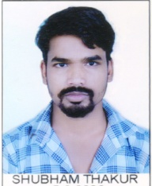

**Phone:** +91 8463851122  
**Email :**thakurshub281@gmail.com

**SHUBHAM THAKUR**

**PROFILE**

To be a successful professional in a Globally Respected Company and to achieve the objectives of the company with honesty and to continuously upgrade my knowledge and skills.

**EDUCATION**

**Bachelor of commerce** Graduated, July 2017

Swami Vivekanand PG collage Narsinghpur, 52.93%  
RDVV University Jabalpur Division 2

**10+2** Graduated, July 2014JNV BOHANI, NARSINGHPUR Marks 62.6%  
CBSE Board Division 1

**SKILLS**

* Self awareness
* Problem solving
* Interpersonal Relationship
* Coping with stress
* Decision making

**WORK EXPERIENCE**

21 month in NBFC Sector as Cashier / Back office

**COMPUTER PROFICIENCY**

* Word 2010
* Excel 2010
* Power Point 2010

**LANGUAGES**

* Hindi
* English

**PERSONAL DETAILS**

Father’s Name:- Mr. Rakesh Thakur

Marital Status:- Single

Birthday:- May 27, 1995

Nationality:- Indian  
Gender:- Male

**Declaration**

I, Shubham Thakur, here by declare that the information contained herein is true and correct to the best of my knowledge and belief.

Shubham Thakur

Kareli Narsinghpur ,MADHYAPRADESH  
Date :-