**RESUME**

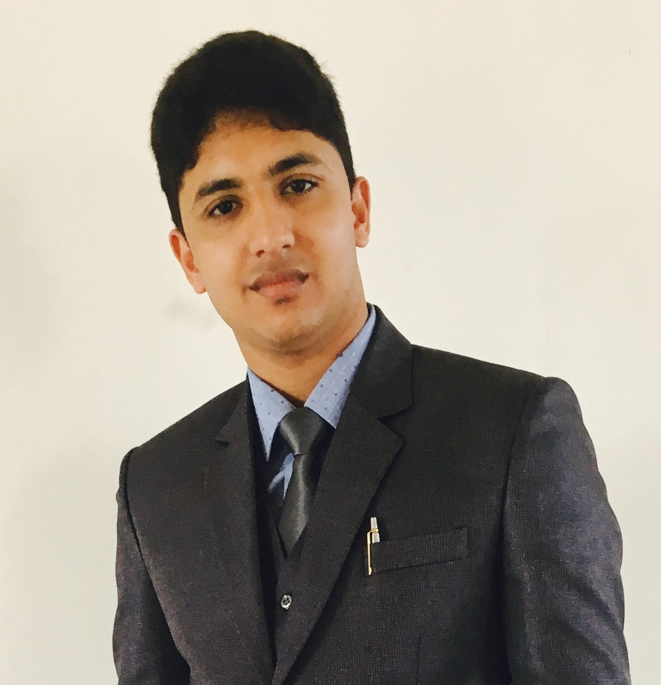

**Ravi Kamboj**

**DOB:-** 03-10-1995

**Father Name:-** Mr. Sushil Kumar

**Address:-** Ward No.1 Indri

**Distt:-** Karnal (Haryana)

**Pin Code:-**132041

**Contact No:-**9034302339

**Email:-**[gagderavi1995@gmail.com](mailto:gagderavi1995@gmail.com)

**Objective:-**To contribute to the growth of the particular organization. To make possible efforts to increase the goodwill of the organization.

**Academic:-**

|  |  |  |  |
| --- | --- | --- | --- |
| **Qualification** | **Institute** | **Board/University** | **Percentage** |
| MBA  Marketing+IB  (2017-2019) | GGGI (Ambala) | Kurukshetra University | 69% |
| BBA  (2014-2017) | GGGI (Ambala) | Kurukshetra University | 71% |
| 10+2 | S.U.S (Indri) | HBSE | 68% |
| Matric | H.C.P.S (Indri) | HBSE | 82% |

**Work Experience:-**

**SATYA MICRO CAPITAL LTD.**

(NBFC & MFI)

**Department:-**Operation

**Designation:-** Assist. Manager

**Roles and Responsibility:-** Handling all the operational activities of a Haryana state and coordinate with field executives and all branch head.

**Special Training:-** **(i)** Summer Training in (BCS India PVT LTD.) 2016

**(ii)** Pearl Export & Import (Ludhiana). 2016

**(iii)** Moonlight Tools (Ludhiana). 2018

**(iv)** Honda Two Wheelers Pvt Ltd. (Rajasthan) 2019

**Activities:-** Participated in Quiz Competition (2013).

Participated in (Startup India Summit) Nov. 2016

2 Days Business Workshop (Vardhman Textiles LTD.) Himachal Pardesh

Attend Seminar in (Business Standard Pvt Ltd) Chandigrah

**Special Skills:-** Proficient in M.S Office, Tally, E-Log, Page Maker, PhotoShop , Dos , Web Designing , Computer basics.

**Personal Skills:-** Good Communication skills , problem solving capacity

Confident and Hardworking , Leadership Quality

Management Skills , Marketing Skills, Business Management capacity

**Languages:- (i)** English

**(ii)** Hindi

**Date:- Ravi Kamboj**

**Place:-**

**(Signature)**