RESUME
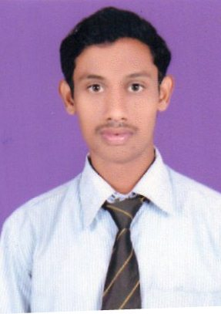

Mr. Pramod Datuji Dhole At Post-Masod
Mo. 96572416994 Taluka-Katol
pdhole435@gmail.com District-Nagpur-441103

CAREER OBJECTIVE:-

As a serious employee of the business dynamics, I shall do my best to contribute to the success of the organization as a part of a progressive & professional team. As well looking for the growth in motivation & committed environment.

EDUCATIONAL QUALIFICATIONS:-

Qualifications | Board/University | Year of Passing | Percentage
M.B. A. (Mrk& | Nagpur University | Appear | Appear
B.com | Nagpur University | 20141414 12 | 48%
HSC | Nagpur Board | 2011 | 60.00%
SSC | Nagpur Board | 2009 | 69.69%

WORK EXPERIENCE:-

1) Naargo industries pvt. LTD.(Tormac Pumps ) Nov 2016 to till date

Agri.Ecupment & Domestic
Product =Agree & Domestic water pump
Area =Nagpur city, Nagpur,Amrawati,Akola and Buldhana District

DESIGNATION: - Sales & Marketing Executive
Having Three year work experience.

Duties Carried out by me:-

> Business development
> Setting marketing objective.
> Achive local as well as Nation target.
> Implementation of marketing & sales aspects to generate more business.

2) Eureka Forbs Ltd. June 2015 to Nov 2016
Nagpur
Produt = water & Air Purifier

Area = Nagpur city
DESIGNATION = Sales Executive
Having a one year work Experience

3) ICICI BANK Ltd. KATOL BRANCH
March 2014 to April 2015
Product = KTL & Agree Loan

Area = Katol Tahsil
DESIGNATION = LOAN Executive
Having one year work Experience

COPMUTER SKILL:-

> Tally 0.9
> MS-CIT
> Internet
> Microsoft Office

PERSONAL DETAILS:-

>  >  >  >  > | Date of Birth :  Gender :  Marital Status :  Nationality :  Known about Languages : |  | 02 Jan 1993  Male Unmarried Indian  Marathi, Hindi & English
CONTACT DETAILS :-
> | Name : | Mr. Pramod Dhole. Dhole
> | Current Address : | Plot no. 5 Near S.B.Traders.
 |  | Ganesh Nagar Daba wadi, Nagpur 440023
> | Mobile : | 9657241694
> | Email ID : | Pdhole435@gmail.com

DECLARATION:-

I here by declare that the above mentioned information is correct up to my knowledge. here the responsibility for the correctness of above-mentioned Particulars.

PLACE: - Nagpur

Date :- 26/06/2020 Pramod Dhole

