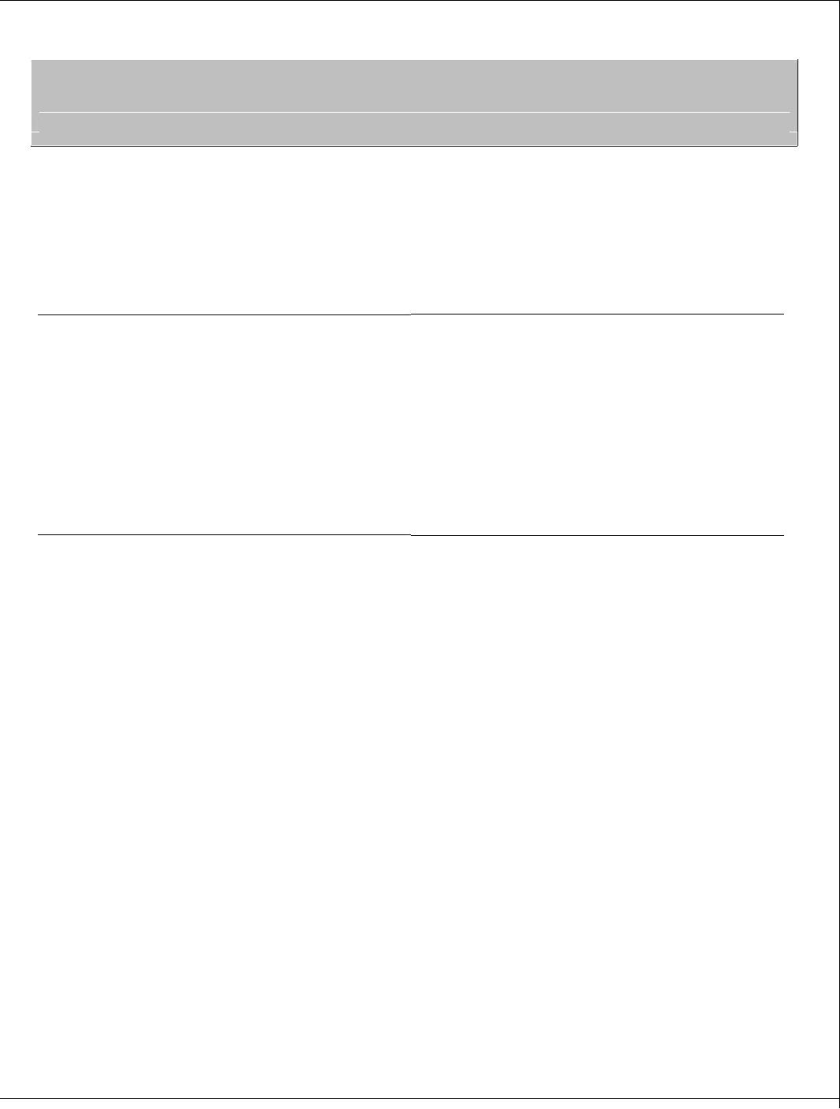**7Utpal Kumar Sahoo**

**09034683321** **sahoout3@gmail.com**

**Seeking assignments with a growth oriented organization in Banking & Finance Industry.**

**PROFESSIONAL ABRIDGEMENT**

* **A dynamic professional with 4 year experience as Branch Team Leader and regional team member in Shriram Transport Finance Company Limited From sep 2018 to Aug 2018.  **
* **Worked As Shift Engineer In Icon Facilities Pvt Ltd, Gurgaon Haryana from sep 2012-Sep 2013 in Multistorey Building MainteneceSector** .

** **

* **Worked As Graduate Engineer Trainee In CenotechIndia PvtLimited which deals with solar systems and earthing.**
* **Presently working as SALES MANAGER IN HDFC BANK LIMITED IN RETAIL ASSETS,CAR LOANS DEPARTMENT.AT JHOLA SAHI, CUTTACK.**
* **  **

**CAREER CONTOUR**

**Working As Sales manager from aug 2018 to present in HDFC BANK LIMITED**

**Job Profile:**

* Responsible for generating new business in Car Loan and Commercial vehicle finance by handling direct team,channel sourcing and free lancers in Car segment like Hatch Back,Sedan,MPV,MUV and in commercial segment like scv,lcv,icv,mhcv and bus segments in assigned area and open market.
* Maintaining and developing relations with dealer and to utilize it in generating revenue and getting business for the company.
* Developing proposals and offering rates to existing and new customersand to close the deals with monitoring complete processing till disbursals.
* Creating and developing a team of Subordinates , including fields officers ,sales coordinators.
* Present new products and services to the prospective client and enhance existing relationships.
* Responsible to achieve Assigned Area targets in Car Loans and commercial vehicle Finance segment.
* Working As Sales head of the Assigned Area
* Handling and distributing work tasks to the team of 15 field executives comprising two credit executives, two account executives and one customer representative executive.
* Ensuring the TAT specified for the task as per quality for enhanced customer satisfaction level.
* Generating lead for Car loan for new and used Car through walk in customers and visiting different dealers and transporters .
* Adept in interfacing with customer for understanding their requirements or problem & suggesting the most viable solution and promoting relation with customer.
* Identifying proper child loan like Tyre Loan, Gold Loan, Insurance Loan etc for needy existing customer and cross selling product of group companies.
* Monitoring all documentation process (Pre & Post)
* .
* Pre-Closure settlements, final settlements and closures of loan account.
* Ensuring the Credit policy implementations.
* Responsible for Overall Performance of the Branch.
* Facing the entire operation audit.
* Understanding Branch activities.
* Identification & Assessment of customer.
* Learning document process (Pre & Post), RTO procedure.
* Understanding Collection of NPA Customer, Expired Accounts, on Starters & dealing with problem Accounts,
* Vehicle Seizure, Disposal of repossessed vehicle.
* Learning Credit Administrative, collection and conduct of account, Lead management procedure.
* Complete assessment of all vertical.
* Learning operating economics for new and old vehicle for financing and fixing installment.

**Technical skills**

* Computer Skill : Basic C, C++,Microsoft Word,Excel, Powerpoint.
* Operating Systems : Windows XP, Windows 7, windows 8, Windows Vista etc.

**EDUCATION**

**2012** B.E.(Electrical and Electronics Engineering) from Barrister Ranjit Mohanty International Institute of Technology with 65%

**2008**cbseKendriyaVidyalayaCuttack,Odisha with 65%.

**2006**CbseKendriyaVidyalaya,Cuttack , Odisha with 80%

2019 Completed MBA From DDCE,Utkal University,Bhubaneswar

**Extra-Curricular Activities**

* TablaPlayist
* National cricket Player 2010
* Interacting with people.
* Travelling and exploring to new place
* Listening Old Music

**PERSONAL DOSSIER**



|  |  |  |  |
| --- | --- | --- | --- |
| **Date of Birth** | **: 2nd May, 1991** | **Gender** | **: Male** |
| **Father Occupation** | **: Service (Govt.Of India)** | **Marital Status** | **: Single** |
| **Father Name** | **: Arjun Kumar Sahoo** |  |  |
| **Address** | **:At-Srikaroaun ,Gopalpur,Cuttack,Odisha.** | |  |
| **Languages Known** | **,**  **English, Hindi,Odia Bengali,** | | |
| **Date:** |  |  |  |
| **Place:** |  |  | **(Utpal Kumar Sahoo)** |