RESUME 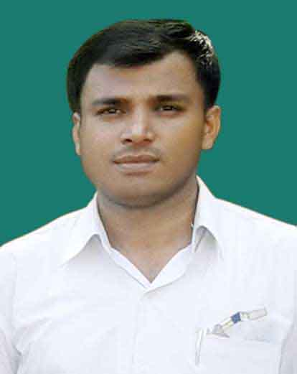
HARISH CHANDRA VERMA
Contact No. 09140153448
Address- SA 18/71 D C Kuntivihar colony, sarang talab, mauja po-tapovan ashram VARANASI
Pin – 221007
email.- hharish_99@rediffmail.com ,
harish9580289173@gmail.com
Objective:

To obtain a position in a success oriented company that seeks an ambitious and career conscious person, where acquired skills be utilized growth and advancement both professionally and personally.

PERSONAL STRENGTH:

Work With Dedication and Determination.
High Energy Work Ethic and Commitment to Customer Service.
Easily Adaptable to Any New Technology with Minimum Training.
Ability to Work Individually, in Group.

ACADEMIC QUALIFICATION:

High School from U.P Board in the year 1994.
Intermediate from U.P Board in the year 1996.
Graduation from IGNOU in the year 2005
DIM from IGNOU June 2012.
PGDIM in from IGNOU December 2014
PGDMM from IGNOU june 2014
M.B.A, MARKETING from IGNOU.june 2015

PROFESSIONAL QUALIFICATION:
DCA from ERA 21st COMPUTER Varanasi 2004.
Diploma in Co-operative Management by State Government (U.P) 2007 Mega-tech in computer Hardware & Networking By ( MTICE) 2012.
Black belt in Martial arts (karate) 2nd Dan 2001.
Civil defence services in get training of fire-fighter by gov 2013.

OTHER SKILL
Windows applications & good known computer maintenance, Management handling my self.

EXPERIENCE:

- Computer maintenance and trouble shooting in market by self 2005-2013.
- Installation of Server Operating System and Client Operating System, Packages & application..
- PC Assembling, Hardware Troubling Shooting
- Troubleshoot Network Problems & handling queries. And Solving hardware problems & Preventive maintenance.
- PC Assembling, Hardware Troubleshooting, Formatting
- Uttar Pradesh HANDLOOM co-operative society viewers marketing in manager 2008 .
- DNA(Daily news activist) Marketing Manager 2013
- Marketing Manager in ICN NEWS UP(Electronic Media) . 2014
- CURRENT JOB -ASSESSOR IN IT SECTOR ELECTRONIC COMPANY.
C&K MANAGEMENT LTD (ESSCI) . (NSDC)PMKVY .

- Interests-Travelling, international affairs, market, research, sports activity, Get the knowledge & study.

PERSONAL DETAILS:

Date of Birth : 15-7-1978

Father’s Name : Dinesh Chandra verma

Mother’s Name : indra verma

Nationality : Indian

Religion : Hindu

Gender : male

Marital Status : married

Category : OBC

Languages Known : Hindi & English

DECLARATION:

I hereby declare that the above written particulars are true to best of my knowledge’s belief.

DATE: ……………….
PLACE: ……………… Signature

