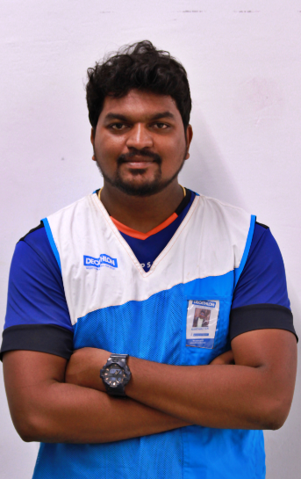

**Name - R. karthikeyan**

**E-mail- - karthikeyan.ramachandran@decathlon..com**

**Contact no -+91 8668144101**

**Experience – 2 above**

|  |
| --- |
| **CAREER OBJECTIVE** |

A dynamic sports leader, having 2.1 years of experience in Decathlon. Played a role of a User Happiness leader for 6 months & 1 year in FLX &(CRM), 5 Month in Domyos, have strong layout knowledge & experience, very strong in LSP & service oriented towards customer. Have robust product knowledge hence looking for opportunities in production thereby to contribute and learn in this function. Aiming to become a Retail Supplier by 2019 in Decathlon

**Summary:**

* Initiated and organized 6 store level & 2 city level events successfully
* **Master in CRM which makes decathlon poonamallee 6 times DSI podium topper**
* Maintained least shrinkage of 0.25% which is least in DSI
* Created innovative displays & more user friendly displays in layout
* Excellent skills in MS Word, MS Excel, MS PowerPoint and Internet
* Proven positive attitude, ability and willing to learn new things quickly and to work under pressure
* Strong Communication, Interpersonal and Presentation skills
* Committed & Self-motivated and can work with team as well as independently

|  |
| --- |
| **WORK EXPERIENCE** |

**Current Employer**: Decathlon Sports India Pvt Ltd,

**Domain**: Retail

**Designation:** Sports Leader

|  |
| --- |
| **WORK AREAS AS ON DATE** |

* **Layout**
* Layout is maintained and changed frequently as per business needs, Sales, Season & made user centric
* Involved more creative ideas and new strategies of sales according to season.
* Highlighting 5/40’s more technically and 80/20’s more commercially
* **Economic Performance**
* Achieved targets by using all sales strategies by local catchment’s
* Achieved 90% of YTD ambition

**Sales and Service Oriented**

* **Given the best service to the user and created many customer as a user in Decathlon & Got a Raving Fan award in march D3**
* Suggested best products to the customer with product knowledge & Created long term users in decathlon
* **Events**
* Conducted Apartment , corporate events in the store level and also 3 cricket events and initiated a brand level event **PAD UP CHALLENGE**  for users to practice their sport
* Upcoming events 1. Bench press , Pilates event for pregnant ladies
* **Daily Manager**
* As a daily manager helped in operating the store in the best in class way, with zero discrepancy
* Helped in store operation priorities and completed with zero errors in given period of time
* Applied all best practices in the store level & made team mates happy and enthusiastic
* **Product Training**
* Trained many full time and part timers by giving 100% product knowledge and elevated them
* Groomed my team members by giving best technical knowledge about the products
* **PnL**
* Well versed with cost piloting and PnL piloting helped me know the complete business process of Decathlon
* Have shared knowledge to team members on PnL

**Previous Company**: QUEENS LAND

**Domain:** CUSTOMER RELATION

**Designation:** FRONT OFFICE MANAGER

|  |
| --- |
| **EDUCATIONAL QUALIFICATIONS** |

* Completed B.E EEE from Apollo Engineering college, Chennai 2015.
* Completed 12th from Tagore Matriculation higher secondary school in 2011.
* Completed 10th from St. john’s Academy in 2009.

|  |
| --- |
| **IT CREDENTIALS** |

* **Microsoft Office:** Word, Excel, PowerPoint. Adobe: Illustrator, In Design Extensive, Research skills, including database, Internet, experimental Research.

|  |
| --- |
| **AREA OF INTERESTS** |

* Logistics and Supply Chain Management
* Total Quality Management & production system

|  |
| --- |
| **SPORTS ACHIEVEMENTS** |

* **Played inter College Leather ball cricket matches**
* **Intermediate volleyball player**

|  |
| --- |
| **PERSONAL INFORMATION** |

**D.O.B:** 28-08-1994

**Permanent address:** 1476 Mgr street , pappanchatram , Poonamallee (via) Chennai-600123

**Languages known:** English, Tamil.

**Father’s Name: R.Ramachandran**

**Mother’s Name – R.Saraswathi**

I hereby declare that the above given information is true to the best of my knowledge and belief.

Place: Chennai

Date: R.karthikeyan