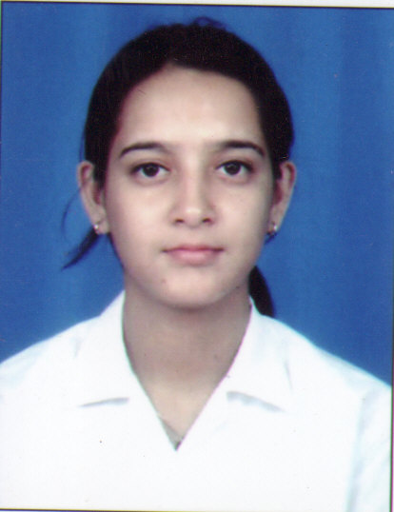
CURRICULAM VITAE

Name – Pallabi Basu
Daughter of – Mr. Pranab Kumar Basu
Permanent Address – 27, Sarat Ghosh Street
Kolkata – 700 014
Phone No. – (033)22492553
Mobile No. – 9804462295
E-Mail Address – pallabibasu@gmail.com

Academic Qualification :-

Year | STD | School | Board | Percentage
2004 | 10th | Loreto Day School Sealdah | WBBSE | 60.4%
2006 | 12th | Loreto Day School Sealdah | WBBHSE | 68.9%

Professional Qualification :-

Completed final semester of 3 years Degree Course in Hotel Management & Catering Technology from Punjab Technical University, with 6 months internship from Leela, Goa.

Experience :-

COMPANY | DURATION | DESIGNATION
COGENTECT SOLUTIONS,KOLKATA | 03 MONTHS | CCE
WIPRO BPO, KOLKATA | 10 MONTHS | CCE
LEELA KEMPINSKI, GOA | 06 MONTHS | INDUSTRIAL TRAINEE
CALCUTTA CLUB | 5 MONTHS | FRONT OFFICE EXECUTIVE
Bose Corporation Insia Pvt Ltd | 6 MONTHS | DEMONSTRATOR

Objective – To work as an efficient employee in a company that offers
Good opportunities and growth.

Personal Information

Hobbies : Travelling, Listening to music.
Interests : Reading books, Internet Surfing.
Languages Known : English, Hindi, Bengali, French (Elementary).

Vital Statistics & Physical Features
Date of Birth : 22nd August, 1987 | Sex : Female
Nationality : Indian | Height : 5’ 4”
Religion : Hindu | Weight : 58 Kgs

Date – 11/10/2010

Pallabi Basu

