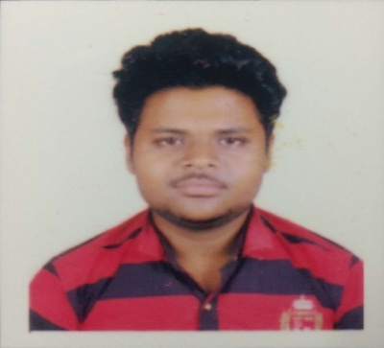
CURRICULUM VITAE

LALIT KUMAR BEHERA
Ph. No.: +91-7008615104
Email Id: lalitbehera6@gmail.com

Carrier Objective
To ascend the corporate world by utilizing my skills and abilities and accept the challenges of present scenario mindfully to achieve the goal, taking every moment as a moment of creation with sky as the limit.

Academic Qualification
Course | Board/  University | Institute | Year Of Passing | Percentage/  CGPA
10th | BSE  ODISHA | SSVM,COLLEGE SQUARE,CUTTACK | 2011 | 60%
Diploma | SCTE&VT  ODISHA | DRIMS  TANGI,CUTTACK | 2014 | 70%
B.Tech in Mechanical Engineering | BPUT | GOVERNMENT COLLEGE OF ENGINEERING, KEONJHAR | 2018 | 6.5
Strength
- Responsible and good at doing job conscientiously.
- Able to work in a group as well as individually.
- Analytical skills.
- Self motivated and self-confident.

Skills
MS OFFICE, CATIA, Master CAM,CNC Machining, CREO Course,
Conventional and Non-conventional Workshop
Experience
1. 1Year 3 months worked at Bajaj Finserve Compnay Ltd As a Role of senior sales officer.
2. cars dekho 1 year 2month experience in this company As a assistant manager.And also Handeling 12 members of team under myself.
3.presently working in reliance industries LTD as a distribution officer.working since Aug 2020.
INTERNSHIP-previosly started carrier in bihariJi container private ltd. Nit vi. (Manufacturing of lpg cylinder)as a position of quality control incharge 4/8/2017 to 4/8/2018.
Hobbies
- Playing Cricket & other Games
- Reading Books
Personal Profile
Date of birth : 20th July, 1995
Father’s name : Mr. Rajendra Behera
Mother’s name : Mrs. Jayanti Behera
Marital Status : Single
Sex : Male
Nationality : Indian
Languages Known : English, Hindi and Odia.
Address : At-Preswar sahi,Jobra
P.O.-College Square
Dist -Cuttack
Pin- 753003
State- Odisha

Declaration
I do hereby declare that the statements given above are true, complete and correct to the best of my knowledge and belief.
PLACE:cuttack
DATE: 12.9.2020

