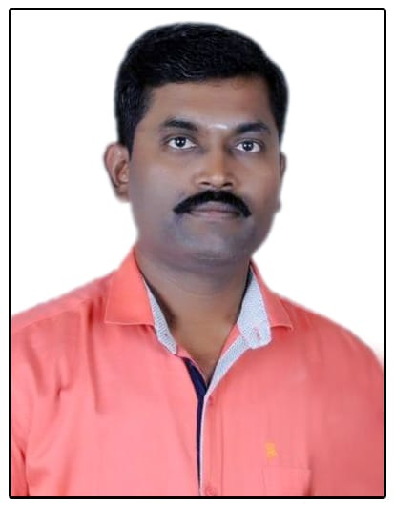**FROM**

Subedar K Loganathan(Retd)

4/373-A-2, K K Illam,

Godhawari Street, Bama Nagar,

Anaiyur-Post, Madurai-Dist,

PIN-625017, MOB- 9426722850

E.Mail : [loga11575@gmail.com](mailto:loga11575@gmail.com)

**Sub** : Kindly consider for employment at your esteemed institution.

Respected Sir,

1. I, JC-440709Y Subedar K Loganathan retired from Army service with effect from 29 Feb 2020 in MADRAS Regimental Centre, Wellington(Nilgiris). After an unblemished color service of 27 years and worked as a part of 7(TN) BN NCC, NCC group HQ, Madurai for 02 years tenure as an Instructor for Collages and Schools in the rank of Havildar Major and also Serving with an Instructor for Leadership Management Course at Junior Leaders Academy, Bareilly for 03 years tenure in the rank of Naib Subedar.

2. As a Part of my Army service, I have successfully completed my civil qualification in M.A(Public Administration) and PG Diploma in Human Resource Development and also performed the various duties in Various rank as a Computer Operator, Store Holder, Kote NCO, Ration NCO, Subedar Adjutant and Senior Quarter Master.

3. As above, May I request you to kindly consider my name for employment at your institution as and any suitable vacancy arises. My resume and support documents are enclosed here with.

4. Hopping your favorable reply. Thanking you.

Yours faithfully,

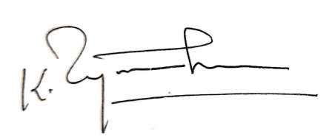

K LOGANATHAN

**OBJECTIVE :**

Challenging and responsible position which would effectively utilize prior experience, training and abilities for professional growth and advancement.

**STRENGTH AND EXPERIENCE :**

27 Years experience with a variety of Arms and Equipment’s, Professional persons with training and Store Management, High Supervisory skills and management abilities.

**AWARD AND PERFORMANCE :**

* Awarded in General Officer Commanding-in-Chief Commendation Card on 15 Aug 2014.
* Selected to Participate the Leadership management programme at NCO’s Academy,

Fort Billis, Texas, USA in Apr-May 2011,

**ARMY COURSES :** Quarter Master Course(Grade-A), **:**  Junior Leaders Course(Grade-AI)

**CERTIFICATE COURSES :** Fire Officer and Security Supervisor.

**:** Diploma in Computer Application & Networking.

Network Administrator/Wireless Networking & Cyber Security.

**SKILL SET :** To cooperate and coordinate with team to achieve the organization goal.

**BIO DATA**

**NAME - K Loganathan**

**FATHER’S NAME - R Kandeepan**

**DATE OF BIRTH - 11.05.1975**

**ARMY EXPERIENCE - 04 May 1993 to 29 Feb 2020**

**BLOOD GROUP - O+ve**

**MARITAL STATUS - Married**

**NATIONALITY - Indian**

**RELIGION - Hindu**

**CHARACTER - Exemplary**

**EDUCATION - M.A , PG Diploma in HRD**

**LANGUAGE KNOWN - Tamil, English, Hindi, Malayalam**

I certified that the above information is correct to the best of my knowledge and belief. Thanking you.

**Place :** MaduraiYours faithfully

K Loganathan