**Juilee S. Sathone**

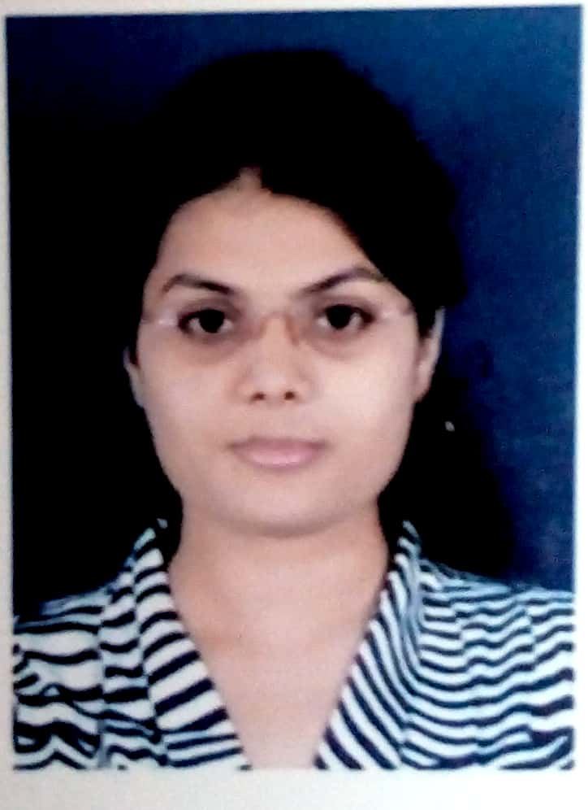

**Mobile:** +91-7387533089

**E-mail:** [juilee.sathone@gmail.com](mailto:juilee.sathone@gmail.com)

**Career Objective**

----------------------------------------------------------------------------------

To seek a challenging position as an Electronics Engineer with an organization of Repute where I can utilize my knowledge for the growth of the organization.

**Synopsis**

---------------------------------------------------------------------------------

* A self-motivated individual Completed **Master’s degree** in electronics (VLSI & EMBEDDED) 

Engineering, and holds a Bachelor‟s Degree in Electronics Engineering**. ** 

 

* Attended a workshop at IIT Bombay on **sixth sense robotics** in 2014.   

 

* Attended a VLSI & Embedded design Conference at Hyatt Hotel,Pune 2018   

 

* Participated in National level project competition.   

 

* Participated in Various short-duration workshops like - Future Trends In CMOS VLSI & IoT.   

 

* **Published** Paper on“Greenhouse Monitoring Using Advance sensor technology and Biogenetic 

Technology” for an International Conference on Engineering and Technology (ICET-15).  

 

* **Published** Paper on“Thresholding approach based on test cell statistics”.International journal onVLSI  

and Signal processing (IJVSP-2018) ISSN: 2394-2584. 

 

* **Published** Paper on “OS-CFAR based on Thresholding approach for Target detection”.IEEEConference  

(ICCUBEA 2018). 

 

* Got a **Best Paper Award** as a Researcher in International Conference **ICCUBEA-18** based on my 

ME Project “OS-CFAR based on Thresholding approach for Target detection”.  

 

* Secured 2nd rank in drama competition in VNIT, Nagpur.   

   

* Was part of the team was Runner-up in Women Cricket Tournament.

# Professional Experience Summary

## ---------------------------------------------------------------------------------**Organization:** Dhoot Transmission Pvt. Ltd., Chakan , Pune

## **Total Experience:** 1 Year( April 2018 – May 2019)

## **Designation:** Trainee Engineer

**Projects Undertaken**

1. **During M.E**
   1. **Title :** Thresholding approach Based Test Cell Statistic

**Software :** MATLAB

**Working:** This is a project of **ARDE DRDO**, Pune and Sponsorship given by **Center of excellence, COEP**, Pune.

**Description:** In this project we designed a algorithm based on CFAR and compare it. Various typesof CFAR Algorithm to detect a Target Accurately through RADAR Using a OS-CFAR method and display result accurately without any noise, error, echo etc. currently workig on 2-D OS CFAR for accurate detection.

* 1. **Title :** Design of 6 T SRAM cell

**Software:** Mentor Graphics

**Description:** In this we designed 6T SRAM cell with the help of Mentor Graphics tool. We per-formed Transient Analysis of the design and calculate delay and power dissipation.

1. **During BE**

**Duration**

**:** 40 weeks

**Project Title**

**:** Rose harvesting using „Raspberry PI‟ embeddedsystem.

**Technologies Used :** Python language

**Project Objective** **:** To harvest bloom roses using robotic arm.

**Project Description:** This project investigates the accuracy and effectiveness of harvesting therose flowers using Open CV and Raspberry Pi.

1. **During DIPLOMA**

**Duration:** 25 weeks

**Project Title:** Cell phone operated land rover (Robot).

**Project Objective:** To create a Robot which can be used by Military Personnel to scrutinizethe Enemy Area?

**Technologies Used**: Microcontroller c language.

**Project Description**: With this very basic concept of cell phone operated land rover, we can move themotor forward backward and turn right left respectively as per the command given by the cell.

**Domain and Technical Skill**

|  |  |  |
| --- | --- | --- |
| **Operating Systems** | : Linux, Window-7, 8, 10. | |
| **Programming Languages** | : C, C++, VHDL and Python. | |
| **Software Tool Use** | **:** | MATLAB/Simulink, Xilinx, Mentor Graphics. |
| **Processors Known** | **:** | 8051, PIC, ARM, Arduino, SPARTAN, Raspberry Pi and FPGA. |

**Academic Background**

**Master of Engineering electronic Engg.**

*Pimpri Chinchwad College of Engineering, Akurdi, Pune.*

**Bachelor of Engineering (electronics)**

*Rajiv Gandhi college of engineering, Nagpur, Maharashtra.*

**Diploma (electronic & communication)**

*Shree datta meghe polytechnic, Nagpur, Maharashtra.*

**Senior & Higher Secondary Certificates** *Maharashtra State Board of Education (M.S.B.E)*

12th Standard (Science)

10th Standard

|  |  |
| --- | --- |
| June 2018 | 8.45 (CGPA) |
| June, 2016 | 7.76 |
|  | (CGPA) |
| May 2013 | 70.23% |

|  |  |
| --- | --- |
| March, 2010 | 52.67% |
| March, 2008 | 74.46% |

**Hobbies & Interests**

▪  Dancing, Travelling, Watching movies.  

  

 

* Communication and embedded system based application, Signal & image Processing.   

**Personal Details**

|  |  |  |
| --- | --- | --- |
| **Date of Birth** | **:** | 29th November, 1992 |
| **Permanent Address** | **:** | 202, shahu nagar, manewada, Nagpur-440034 |
| **Languages** | **:** | Marathi, Hindi, English |