RESUME

TECHNICAL QUALIFICATION : DIPLOMA ENGINEERING.
Institution | Council | Stream | Average % upto Sem | Year of pass  out
Technique Polytechnic Institute, Hooghly(NBA) “A” GRADED COLLAGE | West Bengal State Council of Technical Education | DIPLOMA in COMPUTER SCIENCE & TECHNOLOGY | 67.6 | 2016

TECHNICAL QUALIFICATION : BTECH .
NAME  RITESH KUMAR SINGH | 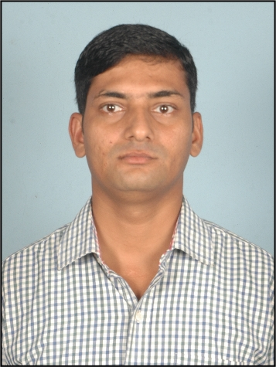
  Mobile | 9330319953 / 9163409323
  E – Mail | riteshdcst25@gmail.com
  Address
  Address | FLAT NO 301,59 DHARMATALLA ROAD,SALKIA HOWRAH ,PIN NO 711106,WEST BENGAL.
Institution | Council | Stream | DGPA | Year of pass out
MCKV institute of engineering.(NAAC) “A” GRADED COLLAGE | MAKAUT,WEST BENGAL UNIVERSITY OF TECHNOOGY (WBUT) | COMPUTER SCIENCE & ENGINEERING | 6.42 | 2019

General Qualifications
Exam | Institution | Board | Subjects taken | % of Marks | Year of Passing
10th Standard | A.N.DEO H.S SCHOOL BAHUARA BALLIA. | ALLAHABAD. | SCIENCE. | 60 | 2007
12th Standard / VOC / ITI | SALKIA SHREE SATYANARAYAN MADHAB MISHRA VIDYALAY. | W.B.H.S.E | SCIENCE. | 45.20 | 2011

FINAL YEAR PROJECT NAME :
STUDENT RESULT MONITORING SYSTEM USING PHP MYSQL,HTML CSS.

Industrial Training :
Company Name & Address | Duration | Subject
E JOB INDIA LIMITED, Vasundhara Complex,1st Floor, NP-9, Physiomax, Sector V, Bidhannagar, W.B-700091. | 30 HOUR | PHP, MYSQL

Computer Skill
Software Packages | : | PHP ,MySQL | Operating System | : | WINDOWS7,XP,10
Hardware | : | ASSEMBANING | Internet Proficiency | : | E-MAIL,S.E.O

Personal Information
Date of Birth | : | 01-07-1992 | Guardian’s Name | : | DIWAKAR SINGH
Gender | : | MALE | Mother Name | : | LATE LALMUNI DEVI
Height | : | 172 | Siblings | : | Brother 3 | Sister 1
Weight | : | 63 | ADHAR Number | : | 304564114916
Blood Group | : | O+ | Passport Number & expiry date | :
Hobbies | : | CRICKET,DRAWING,SINGING.
Languages Known | : | HINDI, ENGLISH, BENGOLI
Achievements / Awards | :

Place : HOWRAH -711106
Date : Signature:
RITESH KUMAR SINGH

