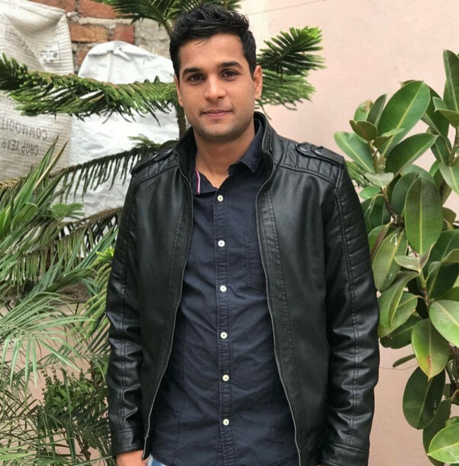

L A K S H A Y

M O R

C O N T A C T

+ 9 1 7 8 9 2 6 5 7 1 7 0

m o r l a k s h a y 3 @ g m a i l . c o m

# P E R S O N A L S U M M A R Y

Hi! I am a hardworking, collaborative, and results-driven Cyber

Security/networking aspirant. Well-versed in improving processes and strengthening compliance. I want to put my ability and skills to best use and make my effective contribution to an organization

# E X P E R I E N C E

## RESEARCH ANALYST

SIMPLILEARN SOLUTIONS PVT LTD | MAY 2019 - MARCH 2020

Creating video contents and articles for my company on Cyber Security and Java topics

Regular Cross-posting on various social media channels to improve the SERP of our video

For reference : [click here](https://docs.google.com/document/d/1iL9qJVe9PaKy-3ls0k-XNxksa-YRnyWh5mRd-0td2xc/edit?usp=sharing)

## TECHNICAL SUPPORT ASSOCIATE

IBM | MARCH 2019 - JUNE 2019

Support the Wood company in 24/7 shifts

Handling all computer related issues on level 2 support

# E D U C A T I O N

## BACHELOR OF ENGINEERING

**REVA INSTITUTE OF TECHNOLOGY AND MANAGEMENT**

**- INFORMATION SCIENCE AND ENGINEERING**

2014 - 2018 | PERCENTAGE - 59

# S K I L L S

CEH(Certified Ethical Hacker) course Networking

Knowledge of SQL C, C++, and Java

Content development Article writer

Communication skills

# A C H I E V E M E N T S

**SPORTS**

PLAYER OF THE TOURNAMENT IN BASKETBALL.

SELECTED FOR KARNATAKA STATE BASKETBALL CAMP FOR NATIONALS.

CAPTAIN OF REVA BASKETBALL TEAM.

GOT MANY MEDALS AND CERTIFICATES IN BASKETBALL

**OTHERS**

GOT NCC – CERTIFICATE.

1 POSITION IN DEBATES IN 12 TH STANDARD.

I HAVE PARTICIPATED IN MANY DANCE COMPETITIONS I HAVE BEEN PART OF COLLEGE DANCE TEAM